The Galveston Wharves began a social media campaign on Facebook called Working on the Waterfront Wednesday. The campaign specifically expresses the work being done in and around the port by our construction and maintenance team. By posting new videos of construction projects like the new cruise terminal sign featured on this campaign, we are communicating to the public our utilization of our in-house construction and maintenance team and what we are doing in preparation for the return of cruising.
1. What are/were the entry’s specific communications challenges or opportunities?
With the stoppage of cruising business, the public has been interested in what we are doing to prepare for the return of cruising aside from the upgrades inside our terminals. Before our current Port Director Rodger Rees arrived at the Galveston Wharves our construction and maintenance team was underutilized. Under Rodger’s leadership, the port has begun making the best use of our amazing construction and maintenance team. Our main goal was to highlight this development.
The challenges presented included:
How do we communicate that the Port is making the best use of its resources,
that our improvement projects are mindful of the downturn in business, and the staff is working hard in preparations for the return of cruising.
2. How does the communication used in this entry map back to the organization’s overall mission?
– Explain the organization’s overall mission and how it influenced creation of this entry.
Like most ports in the U.S., the Galveston Wharves is a self-sustaining city entity which means we do not collect tax dollars. Our mission is to generate revenue and then reinvest to create economic growth, jobs, and other benefits for the Galveston region. Our team has clearly defined business goals that support our mission. The Working on the Waterfront Facebook Campaign highlights our commitment to developing and optimizing infrastructure for economic prosperity and our commitment to increasing our revenues and remaining good stewards of our waterfront.
3. What were the communications planning and programming components used for this entry?
Our goals were to achieve a positive value for our 3-Second Video View and improve upon our total minutes viewed for this campaign. By better understanding how long people view our media, we can better understand what elements within the campaign are capturing and engaging our audience. From this understanding, we hope to better influence public perception and ultimately change how they feel about the Port’s resource management.

Our primary audience includes the local Galveston community, existing and future cruise passengers, local and national media, and our stakeholders, local, state, and federal elected officials. Business partners include the ILA, Mobility, Cruise, Stevedores, and Pilots.

Our secondary audience is comprised of community partners including TAMUG, Galveston Chamber, GEDP, GHF/Seaport Museum, Seafarers Center, and the Propeller Club, and the local tourism industry consisting of the Park Board/CVB, Downtown Partnership, and the Hotel/Lodging Association.

4. What actions were taken and what communication outputs were employed in this entry?
– Explain what strategies were developed to achieve success and why these strategies were chosen.
– Specify the tactics used (i.e., actions used to carry out your strategies).
– Detail the entry’s implementation plan by including timeline, staffing and outsourcing used
- Established a rough schedule of key construction developments with the engineering department and our construction and maintenance team. Key dates: Foundation pour, concrete perimeter construction, and lettering & logo installation.
- Video shoots were scheduled each week in time for content creation and publication to Facebook before the following Wednesday.
- Our staff used Canva to create the posts and a DJI OSMO 4 gimble for the video and timelapse footage. All work was done in-house. In addition, we used Canva to help schedule and post the campaign on Facebook.

5. What were the communications outcomes from this entry and what evaluation methods were used to assess them?
– Describe any formal/ informal surveys used, or anecdotal audience feedback received, that helped in evaluating the success of this entry.
– If possible, explain how this entry influenced target audience opinions, behaviors, attitudes or actions.
The campaign featuring the construction leading up to the big reveal of our new cruise terminal sign ran from 12/30/2020 to 3/15/2021. In that time we accumulated a total of 2,804 3 Second Video Views and 739 Minutes Viewed. We found the staff involved in the project received a lot of positive feedback from family friends, business partners, our board members, and the community. Everyone involved with the project's actual construction, from our engineering department to the construction and maintenance team, was found to have enjoyed the showcasing of their beautification project. This had a visible impact on the overall morale of the team, a positive benefit we did not plan for.

https://www.facebook.com/watch/?v=2835258743352183

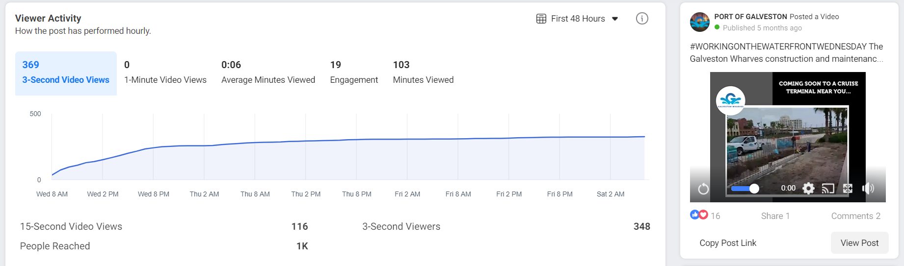

https://www.facebook.com/watch/?v=746687592618986

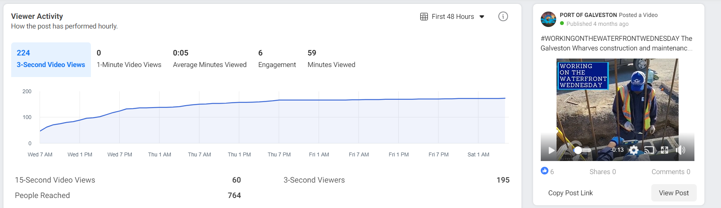
https://www.facebook.com/watch/?v=2945938052301808

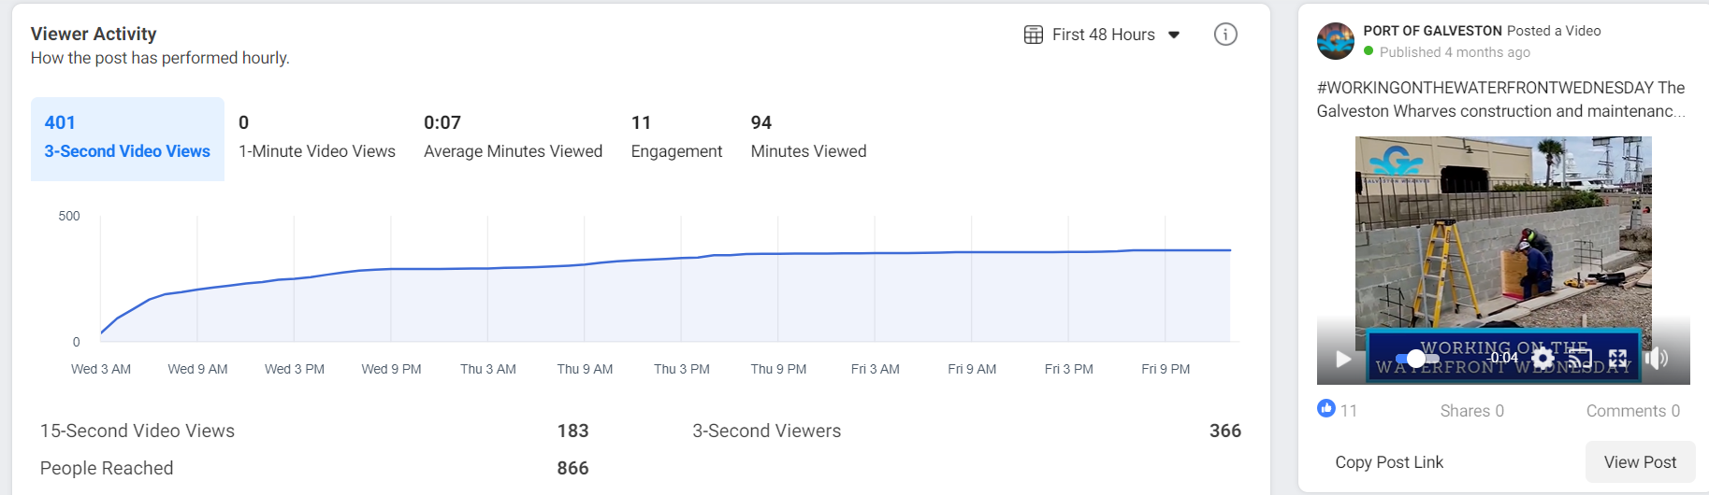
https://www.facebook.com/watch/?v=3413734672086314

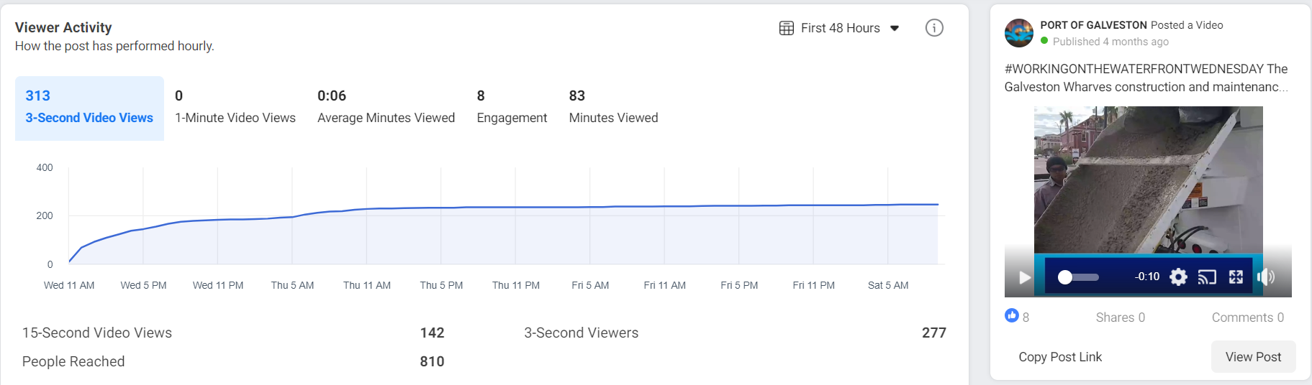

https://www.facebook.com/watch/?v=2945938052301808

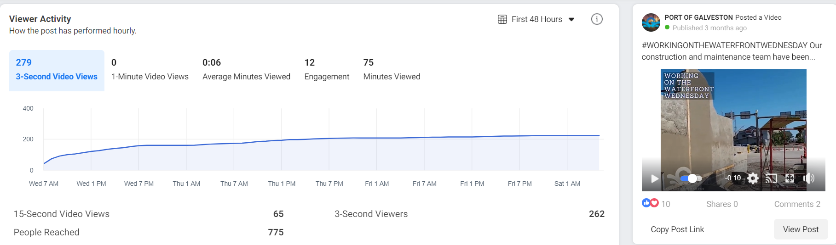

https://www.facebook.com/watch/?v=377048939923438

