The Welcome Home Sail-A-Bration video was created entirely in-house at the Galveston Wharves. Showcasing our Port as the premier location for the resumption of cruising in North America, our communications department put together a short video highlighting the community's support after the arrival of Carnival Cruise Lines Breeze and Vista. The Welcome Home Sail-A-Bration video was created entirely in-house at the Galveston Wharves using the hashtags #WeAreCruise and #ReadySetSail created by CLIA.

1. What are/were the entry’s specific communications challenges or opportunities?
– Describe in specific and measurable terms the situation leading up to creation of this entry.
– Briefly analyze the major internal and external factors that need to be addressed.
During the pandemic, our communications team shifted focus away from cruise operations and began to highlight our cargo activities. With the conversation over the past few months shifting, we felt that the time is now to begin getting excited about cruising again. After the explosion of support on our Facebook page, our goal was to continue the momentum and increase our post reach, 3-second video views, and leverage the CLIA campaigns #WeAreCruise and #ReadySetSail with our recent traffic. After experiencing a high amount of organic activity on our Facebook page, we hoped to continue to see an increase in engagement across our other platforms.
2. How does the communication used in this entry map back to the organization’s overall mission?
– Explain the organization’s overall mission and how it influenced creation of this entry.
Like most ports in the U.S., the Galveston Wharves is a self-sustaining city entity which means we do not collect tax dollars. Our mission is to generate revenue and then reinvest to create economic growth, jobs, and other benefits for the Galveston region. Our team has clearly defined business goals that support our mission. The video highlights our commitment to developing and optimizing infrastructure for economic prosperity and our commitment to increasing our revenues through business development. The hashtags used in this video along with the imagery help define us as a premier cruise port that is ready and waiting for cruising which accounts for 66% of our revenue.

3. What were the communications planning and programming components used for this entry?
– Describe the entry’s goals or desired results (e.g., raise stakeholder awareness/appreciation of the port's new environmental initiatives).
– Describe the entry’s objectives and list specific, measurable milestones needed to reach its goals (e.g., recruit 1,000 volunteers by 6/1/2020 for tree planting).
– Identify the entry’s primary and secondary audiences in order of importance.

Our desired results were 1000 views on each of our social media accounts within 2 weeks of posting and an increase to a positive percentage change of our 3-Second Video Views. Before posting the video we looked at the metrics on Facebook which showed an overall percentage increase for Actions on Page (1288%), Page Likes (2660%) Post Reach (817%), and our 3-Second Video Views were down (65%).

Our primary audience includes the local Galveston community, existing and future cruise passengers, local and national media, and our stakeholders, local, state, and federal elected officials. Business partners include the ILA, Mobility, Cruise, Stevedores, and Pilots. Our secondary audience is comprised of community partners including TAMUG, Galveston Chamber, GEDP, GHF/Seaport Museum, Seafarers Center, and the Propeller Club, and the local tourism industry consisting of the Park Board/CVB, Downtown Partnership, and the Hotel/Lodging Association.

4. What actions were taken and what communication outputs were employed in this entry?
– Explain what strategies were developed to achieve success and why these strategies were chosen.
– Specify the tactics used (i.e., actions used to carry out your strategies).
– Detail the entry’s implementation plan by including timeline, staffing and outsourcing used
Our communications team wanted to create and post a fun video showcasing the community’s support. We rolled the video out utilizing the messaging provided by CLIA’s campaigns #WeAreCruise and #ReadySetSail. As we were planning and executing the arrival of the ships, special care was taken between staff members to obtain the hero shots needed for the video. We produced the video entirely in-house and had to pay particular attention to time as we were under pressure from the events and demands of the administrative functions at the office when completing the final edits for publication the next day.
5. What were the communications outcomes from this entry and what evaluation methods were used to assess them?
– Describe any formal/ informal surveys used, or anecdotal audience feedback received, that helped in evaluating the success of this entry.
– If possible, explain how this entry influenced target audience opinions, behaviors, attitudes or actions.
The Welcome Home video performed well on Facebook with a total of 303 shares, 74 comments, and 3.9K in engagement. The 3-second video views reached 168.2k pushing our overall average minute viewed to 12 seconds. 11,000 of these views occurred in Texas. This proves our drive-in market is ready for cruising at the Galveston Wharves. On Twitter, the Welcome Home video made 523 impressions, 84 media reviews, and 63 total engagements. We also included the video at our last monthly board meeting. Our members of the board were pleased to see our communications department utilizing video media. The meeting along with the video was streamed live on our website which showed an uptick in unique visitors and average visit duration. We recognized that the performance on Twitter and LinkedIn did not meet our expectations. Our team is working on redefining our audience and ways on how we can improve upon our strategies connected to these messaging vehicles.

Facebook Results

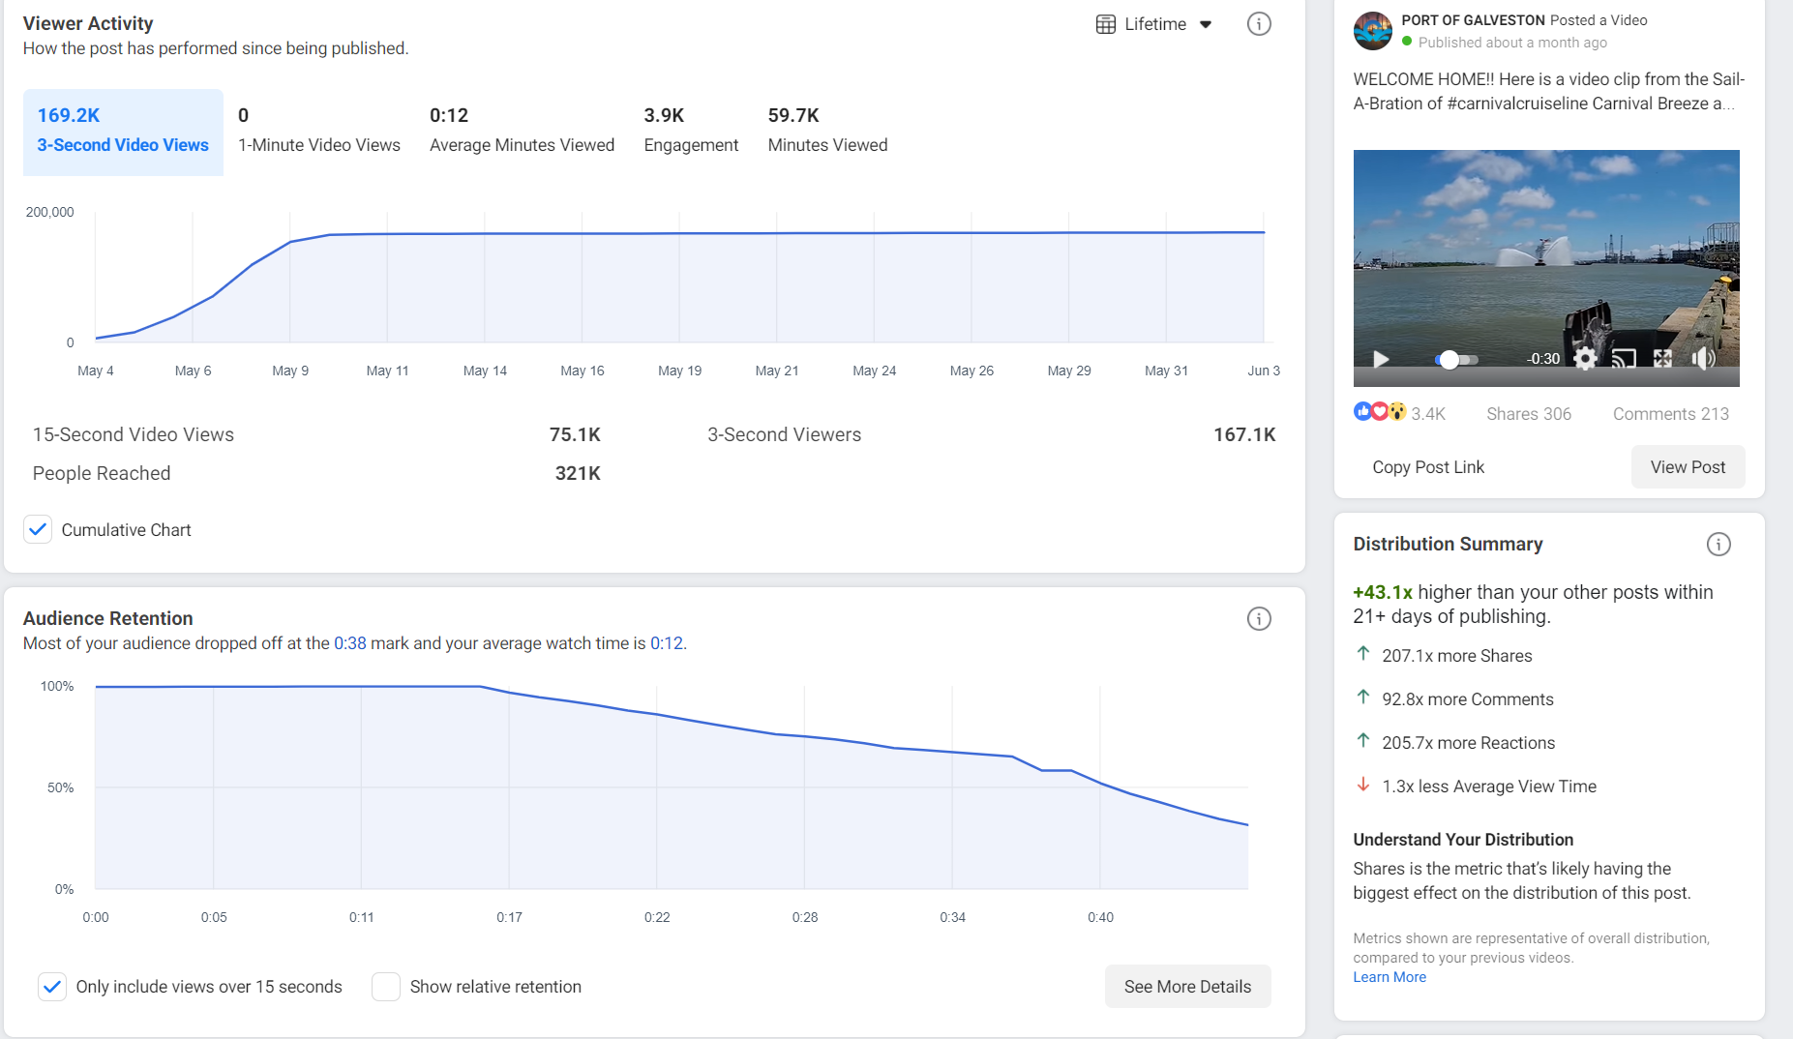Website Results
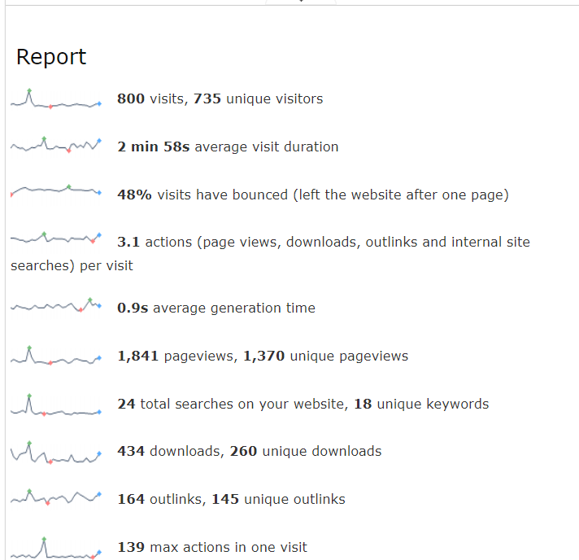
Twitter Results

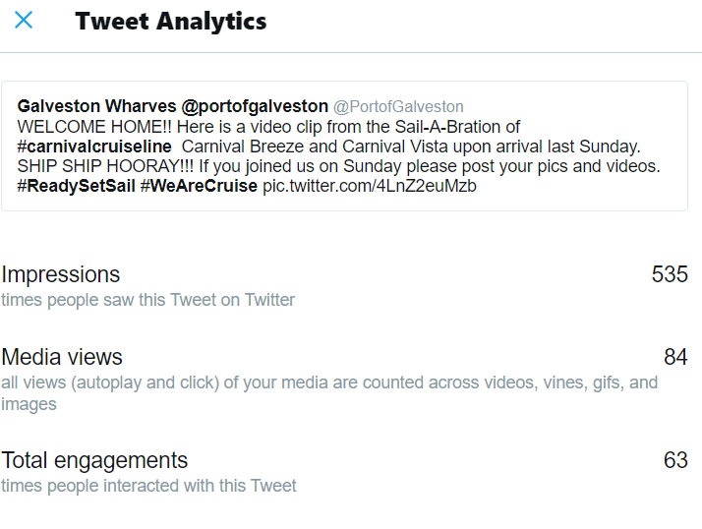

Linkedin Results
