The Galveston Wharves “All Hands On Deck Welcome Home Sail-A-Bration” event on May 2nd of this year was a successful, educational, and overall positive conclusion as we begin wrapping up our efforts in bringing back safe and sustainable resumption of cruising in North America. After a short week filled with regularly scheduled board meetings and tasks, the communications department of (2) put together a Welcome Home Sail-A-Bration; coordinating with Carnival Cruise Lines executives, the rest of the port staff, board members, local workers, and community leaders. On Sunday, as the Breeze and Vista arrived, and close to 500 people showed up to support the return of cruising holding small Texas Flags on a stick and signs we had made with the #WeAreCruise, and #ReadySetSail. “WELCOME HOME” banners were placed on the front and back of our cruise terminal greeting the ships. Our waterfront event quickly gained local coverage that soon turned into hitting the national spotlight. We hoped and planned for 100 or more, and were pleasantly surprised to see what was close to 500 in attendance traveling from as far as Las Vegas, Nevada!

1. What are/were the entry’s specific communications challenges or opportunities?
– Describe in specific and measurable terms the situation leading up to the creation of this entry.
– Briefly analyze the major internal and external factors that need to be addressed.
Our team set out over 5 days to plan and execute the event with a targeted focus on creating as much buzz as possible about cruising at the Port of Galveston and communicating the port as a prime cruise port ready for sailings. We wanted to raise our overall engagement and the number of people reached leading up to the event. Our specific hopes were to see 100,000 people reached and 2,000 in engagements whether it be likes, comments, or shares on our social media accounts.
The pandemic has caused turn-around and lead times to take longer than normal but thanks to the quick response our team was able to secure our purchasing needs. Our goal was to see 200 or more show for the event. Safety concerns were evaluated as having an event during the pandemic presents its challenges. We hosted outdoors and provided hand sanitizer, masks, and space for social distancing.

2. How does the communication used in this entry map back to the organization’s overall mission?
– Explain the organization’s overall mission and how it influenced the creation of this entry.
Our mission tightly wraps around who we are and why we exist. The Galveston Wharves is a self-sustaining city entity that generates and reinvests revenue to create economic growth, jobs, and other benefits for the Galveston region.
Our team has clearly defined what we want to achieve through our mission by assigning goals divided into 5 areas: Financial, Infrastructure, Business Development, Communications, and People. Our financial goals center around increasing revenues and managing expenses. Cruise accounts for 66% of our revenues and our staff since the beginning of the pandemic have been working diligently towards the resumption of cruising. Infrastructure development is another important piece of our business goals. The resumption of cruising is imperative as we begin construction of Royal Caribbean's 3rd cruise terminal at our port. Cruising is a major contributor of labor, taxes, and revenue for existing and new businesses. As communicators of the Port’s business, this event helped strengthen our goal to resume cruising and the publics' perception of this crucial development of our cruise business. Lastly, this event showcased the People centered around our cruise business and the community, ILA workers, cruise passengers, and local and regional businesses.

3. What were the communications planning and programming components used for this entry?
– Describe the entry’s goals or desired results (e.g., raise stakeholder awareness/appreciation of the port's new environmental initiatives).
– Describe the entry’s objectives and list specific, measurable milestones needed to reach its goals (e.g., recruit 1,000 volunteers by 6/1/2020 for tree planting).
– Identify the entry’s primary and secondary audiences in order of importance.
In planning this event during the pandemic, we had to be sure precautions were met. We provided masks, hand sanitizer, and held the event outdoors in an area between our 2 cruise terminals with enough space to practice social distancing. Our goal was to see 100 or more shows for the arrival of the ships. We then created a “Ship Tracker” we then added to our website and social media accounts to give the public a chance to follow up until the day of the event the ship's precise locations. This helped spark interest from the public and we were also able to gauge support. We then created a social media event on our Facebook page. We had over 1000 responses and reached 50,000 people within a few days of the event. Tickets were not sold for this event so we were mainly concerned with providing enough space for the respondents who confirmed as (423) going, (1.3k) interested, and (211) invited. Special approval was granted to access a secured location between CT1 and CT2 large enough while still providing access via our waterfront dining locations on Pier 21.
Our primary audience includes the local Galveston community, existing and future cruise passengers, local and national media, and our stakeholders. This includes local, state, and federal elected officials. Business partners include the ILA, Mobility, Cruise, Stevedores, and Pilots. Our secondary audience is comprised of community partners including TAMUG, Galveston Chamber, GEDP, GHF/Seaport Museum, Seafarers Center, and the Propeller Club, and the local tourism industry consisting of the Park Board/CVB, Downtown Partnership, and the Hotel/Lodging Association.

4. What actions were taken and what communication outputs were employed in this entry?
– Explain what strategies were developed to achieve success and why these strategies were chosen.
– Specify the tactics used (i.e., actions used to carry out your strategies).
– Detail the entry’s implementation plan by including timeline, staffing and outsourcing used

The “Ship Tracker” was added to our website and social media accounts on April 29th to help build buzz around the ship's arrivals.

We then created a social media event on April 30th to track and gauge attendance.

By the morning of John Heald had already posted calling for “all hands on deck” in welcoming the arrival of the ship we then shared to our social media.

We used FastSigns for the banners and signs. Two “Welcome Home” banners at 46’ X 6’ for a total of $1,808.80 and the coroplast signs were $285 which read #ReadySetSail and #WeAreCruise. We utilized our construction and maintenance team to install the large banners. The Texas flags on a stick were also picked up for a total of $18.21.

5. What were the communications outcomes from this entry and what evaluation methods were used to assess them?
– Describe any formal/ informal surveys used, or anecdotal audience feedback received, that helped in evaluating the success of this entry.
– If possible, explain how this entry influenced target audience opinions, behaviors, attitudes or actions.
Select up to 5 files to attach. No files have been attached yet.
The Galveston Wharves working in conjunction with cruise ports in Florida have joined with CLIA in attempting to influence the public perception of safe sustainable cruising with the #ReadySetSail and #WeAreCruise campaigns. Since the pandemic, our port staff has been working hard with our tenants, business partners, local health officials, and the community to resume sailings. Before and after the event we used our social media to gauge the overall change in public perception, we quickly identified the desire within our community and across the region to resume cruising again. Pouring through the posts on our Facebook page, we found countless stories of support for cruising in Galveston. Many who came out to support the return of the Breeze and Vista made signs and posted pictures of them on our social media. The final numbers for the social media event on our Facebook page came out to over 1000 responses and reached 50,000 people within a few days of the event. Tickets were not sold for this event but after we were able to confirm by those who checked in at the event as (423) going, with a total of (1.3k) interested, and a total of (211) invited.
The first to pick up the story was John Heald, Brand Ambassador for Carnival Cruise Lines, who encouraged all those in the Galveston area to attend. The amount of traffic our Facebook page received before and after the event caused our account to be placed under review for fraudulent activity due to the traffic generated. A simple post from the day's event reached 1.2k in shares, 282 comments, and 3k in likes. Below is a comprehensive list of all the local and national coverage. The list is over 100 media outlets including a local market viewership ranging from 30,000 to 300,000 per media outlet.

Play | Carnival Cruise on KENS-SAT (CBS) - San Antonio, TX  Eyewitness News Sunday Morning  5/2/2021 7:07:07 AM  friends or coworkers >>. and still ahead for some carnival cruise ships are well ,they're heading to galveston w . well, doctors say everyone will

Play | Carnival Cruise on KENS-SAT (CBS) - San Antonio, TX  Eyewitness News Sunday Morning  5/2/2021 7:11:54 AM  offering the one dose johnson and johnson vaccination to carnival >> cruise ships are expected to arrive in galveston today. this comes as the cruise industry gears up for a return

Play | Carnival Cruise on KHOU-HOU (CBS) - Houston, TX  #HTownRush Sunday  5/2/2021 7:55:22 AM  galveston is startin to get back to normal. two carnival cruise ships are expected to arrive today. the industry hopes to get back to cruising soon, possibly as early as midsummer.

Play | Carnival Cruise on KTRK-HOU (ABC) - Houston, TX  13 Eyewitness News at 8AM  5/2/2021 9:01:54 AM  closer and closer to the return time. >> i just checked the carnival cruise website. carnival vista and carnival breeze are offshore. they will

Play | Carnival Cruise on Newsradio 740 KTRH - Houston, TX  5/2/2021 12:32:25 PM  is anyone at the John more services kt are reached 24 hour weather center 12 31 our top story to Carnival cruise ship returning to port today the reason mr don't know Yellin people can sail again but it is somewhere out on the horizon Matagorda Bay 24 year-old Jacob Langley was voting with 4 friends on the Colorado River when they had a

Play | Carnival Cruise on Newsradio 740 KTRH - Houston, TX  5/2/2021 1:02:40 PM  wrote Tom collapsing and there are runoffs in both Beaumont and the city of West year due to Carnival cruise ships arrived today at the port of Galveston. Now there were no passengers boarding yet but it is a sign of hope the port say they are having repairs made another work done as they collect crew and that way they'll

Play | Carnival Cruise on Newsradio 740 KTRH - Houston, TX  5/2/2021 1:32:32 PM  31 our top story. There were 9 local mayoral elections yesterday. 7 declared winners in two rescheduling runoff to Carnival cruise ships arrived today at the port of Galveston. No passengers will be boarding yet but they are being worked on. Get ready for summer cruising at least 8 high-profile Republicans are coming to Texas to

Play | Carnival Cruise on Newsradio 740 KTRH - Houston, TX  5/2/2021 4:05:16 PM  around tampa Bay bucs got him and Here's a bit of hope to Carnival cruise ships arrived today in the port of Galveston. Now there were no passengers getting on board yet but it is a good sign. Reports say the they're having some repairs done and mother were done on the two ships and this way they'll be ready

Play | Carnival Cruise on WPMI (NBC) - Mobile, AL  Local 15 News at 5  5/2/2021 5:00:56 PM  legalize et cetera. >> returning home. what carnival cruise lines have returned and what cruise lines will leave from mobile. >> it is a code red sunday as we're tracking a line of storms

Play | Carnival Cruise on KFQX (FOX) - Grand Junction, CO  Modern Family  5/2/2021 5:02:44 PM  es." amy but at least it wasn'tofa carnival cruise. - gloria: i know, sonia! cállate![laughles] who's back--the sangria sisters. i invited so that we could fixour problems.you

Play | Carnival Cruise on KXAS-DAL (NBC) - Dallas, TX  NBC 5 Weekend Report  5/2/2021 5:06:18 PM  the start of the pandemic. today crowds gathered for the arrival of two carnival cruise ships to the port of galveston and the cdc said sailing from u.s. ports could resume as early as july and it is

Play | Carnival Cruise on WPMI (NBC) - Mobile, AL  Local 15 News at 5  5/2/2021 5:08:07 PM  texas. a crowd gathered to celebrate a return of the carnival cruise line. on its facebook page, the cruise line wrote, we are so excited to have our ships back home.

Play | Carnival Cruise on KRIV-HOU (FOX) - Houston, TX  FOX 26 News 5PM  5/2/2021 5:15:51 PM  natalie hee. yeah, that's right, tom, and you can see two of those carnival cruise ships. one of those behind me that one is the carnival vista and over here to my right, the carnival breeze. both of these cruise

Play | Carnival Cruise on KRIV-HOU (FOX) - Houston, TX  FOX 26 News 5PM  5/2/2021 5:17:04 PM  up there. it says we miss y'all that's hanging on the side of one of the carnival cruise ships docked here at the port of galveston now tomorrow, i'm told that nearly 300 crew members will actually be here

Play | Carnival Cruise on WAAY (ABC) - Huntsville, AL  WAAY 31 Weekend News at 5  5/2/2021 5:17:32 PM  again in mid-july. officials are hopeful for the carnival cruise lines to resume its trips from mobile. the area tourism agency says the more than yearlong shutdown has hurt the local

Play | Carnival Cruise on KHOU-HOU (CBS) - Houston, TX  KHOU 11 NEWS AT 5:30  5/2/2021 5:32:51 PM  launched by an american spacecraft. two carnival cruise ships got a welcome as they return for the first time in over a year, greeted by dozens of people eager to get back to cruising

Play | Carnival Cruise on KTRK-HOU (ABC) - Houston, TX  13 Eyewitness News at 5:30PM  5/2/2021 5:36:33 PM  >>> a sign of economic hope in galveston. two carnival cruise ships are docked at the port for the first time in a year. crowds gathered to welcome back the carnival breeze and

Play | Carnival Cruise on WFAA-DAL (ABC) - Dallas, TX  News 8 at 5:30  5/2/2021 5:38:46 PM  ready to set sail? soon? two carnival cruise ships got a warmelcome as they returned to galveston for the first time in more than a year. ted by dozens of

Play | Carnival Cruise on KTLA-LA (WB) - Los Angeles, CA  KTLA 5 News At 5  5/2/2021 5:41:12 PM  covid test. good news is also this a glimmer of hope for the travel industry has 2 carnival cruise ships returned home to the port of galveston texas. >> after more than a year away the ship still aren't allowed

Play | Carnival Cruise on WSMH (FOX) - Flint, MI  Modern Family  5/2/2021 6:02:47 PM  "lethal ladies." amy may have dumped me, but at least it wasn'toff the lido deck ofa carnival cruise. - gloria: i know, sonia! cállate![laughs]- sonia: [giggles] look who's back--the sangria sisters. i invitedmy sister to visit so that we could fixour problems.

Play | Carnival Cruise on KTTV-LA (FOX) - Los Angeles, CA  Modern Family  5/2/2021 6:02:47 PM  i'll bedrowning my sorrows in a marathon of mynew favorite true-crime show, amy may habut at least it wasn'toff the carnival cruise. sonia! cállate![laughs]- sonia: [giggles] look who's back--th i invitedmy sister to visitso that we could fixour problems. you knowlike i never lys borrowed my bras,

Play | Carnival Cruise on KNBC-LA (NBC) - Los Angeles, CA  NBC4 News at 6pm  5/2/2021 6:34:05 PM  >>> another sign of hope in the economic covid recovery. carnival cruise lines are now back in galveston after a long hiatus because of the pandemic. a crowd gathering to celebrate the return the ships to port

Play | Carnival Cruise on Newsradio 740 KTRH - Houston, TX  5/2/2021 7:05:06 PM  Houston food Bank Correa also NewsRadio 7 40 Kate trh good news out of Galveston to Carnival cruise ships arrived today at the port of Galveston. No passengers will be boarding yet but it is a sign of hope the port say they're having repairs may another word and the ships and they're collecting

Play | Carnival Cruise on KTLA-LA (WB) - Los Angeles, CA  KTLA 5 News at 7  5/2/2021 7:37:05 PM  safe to reopen. >> a sign of hope for the travel industry has 2 carnival cruise ships returned home to the port of galveston texas after more than a year away. the ship still aren't allowed

Play | Carnival Cruise on Newsradio 740 KTRH - Houston, TX  5/2/2021 8:05:08 PM  scream, we'll go to the Houston food Bank Kori Olsen NewsRadio 7 40 K trh good news out of Galveston to Carnival cruise ships arrived today at the port of Galveston. No passengers will be boarding yet but it is a sign of hope the port say they're having repairs made another word and the ships and they're collecting

Play | Carnival Cruise on Newsradio 740 KTRH - Houston, TX  5/2/2021 9:05:11 PM  cream. We'll go to the Houston food Bank Koryo sit NewsRadio 7 40 Kate trh good news out of Galveston to Carnival cruise ships arrived today at the port of Galveston. No passengers will be boarding yet but it is a sign of hope the port say they're having repairs may another work done the ships and they're collecting

Play | Carnival Cruise on KPRC-HOU (NBC) - Houston, TX  KPRC Channel 2 News at 10PM  5/2/2021 10:00:38 PM  pushed set to continue tomorrow. one day after 2 carnival cruise ships returned to galveston for the first time in over a year. thanks for joining us. i'm jonathan martinez. i'm see on roads.

Play | Carnival Cruise on KFOX (FOX) - El Paso, TX  Modern Family  5/2/2021 10:02:52 PM  "lethal ladies." amy may have dumped me, but at least it wasn'toff the lido deck ofa carnival cruise. - gloria: i know, sonia! cállate![laughs]- sonia: [giggles] look who's back--the sangria sisters. i invitedmy sister to visit so that we could fixour problems.

Play | Carnival Cruise on KPRC-HOU (NBC) - Houston, TX  KPRC Channel 2 News at 10PM  5/2/2021 10:03:04 PM  they're having conversations with the port of galveston, carnival cruise and royal caribbean about vaccinating employees and passengers. we'll have a press conference urging the cdc

Play | Carnival Cruise on KOMU (NBC) - Columbia, MO  KOMU News @ 10  5/2/2021 10:04:35 PM  celebrate the return of the carnival cruise line to its port. according to the carnival website, trips from

Play | Carnival Cruise on KMID (ABC) - Odessa, TX  Big 2 News at 10  5/2/2021 10:06:18 PM  outlaw abortion. erin a pair of carnival cruise ships docked at the port of galveston today. and while it doesn't

Play | Carnival Cruise on KHOU-HOU (CBS) - Houston, TX  KHOU 11 News at 10PM  5/2/2021 10:06:59 PM  a link to a txdot form to report the damages on khou.com. >> new tonight, two carnival cruise ships got a warm welcome as they returned to port in galveston for the first time in over a year.

Play | Carnival Cruise on KVIA (ABC) - El Paso, TX  ABC 7 News @ 10  5/2/2021 10:08:38 PM  residents lining up to get a glimpse of the pair of carnival cruise ships. no passengers actually boarded them today. but the federal government told

Play | Carnival Cruise on WPSD (NBC) - Paducah, KY  WPSD Local 6 at 10:00  5/2/2021 10:09:24 PM  a crowd gathered to celebrate the return of the carnival cruise line to its port. on its facebook page, the cruise line wrote quote "we are so excited to finally have our

Play | Carnival Cruise on KRGV (ABC) - Harlingen, TX  Channel 5 News at Ten  5/2/2021 10:11:07 PM  vacations again." "today" a pair of carnival cruise ships arrived at the "port of galveston" signaling some "hope" - -for the

Play | Carnival Cruise on KIFI (ABC) - Idaho Falls, ID  Local News 8 @ 10pm  5/2/2021 10:14:27 PM  nats cheering 3 sec there was cheering and celebration as carnival cruise lines sailed into their port in texas. it's been 14 months since passenger cruise ships have

Play | Carnival Cruise on KSAN (NBC) - San Angelo, TX  KSAN 10P News  5/2/2021 10:16:14 PM  home two of its cruise ships.a crowd gathered to celebrate the return of the carnival cruise line to its port.on its facebook page, the cruise line ((brittany))<<.short term...

Play | Carnival Cruise on KBMT (ABC) - Beaumont, TX  Channel 12 News at 10  5/2/2021 10:17:02 PM  the port a crowd gathered to celebrate the return of the carnival cruise line to its port. on its facebook page, the cruise line wrote quote "we are so excited to finally have our ships back

Play | Carnival Cruise on WUTV-BUF (FOX) - Buffalo, NY  2 on Your Side at 10  5/2/2021 10:20:02 PM  to celebrate the return of the carnival cruise line to its port. the carnival breeze and carnival vista took a hiatus due to

Play | Carnival Cruise on KSAN (NBC) - San Angelo, TX  KSAN 10P News  5/2/2021 10:20:05 PM  its cruise ships.a crowd gathered to celebrate the return of the carnival cruise line to its port.on its facebook page, the cruise line wrote quote we are so excited to finally have our ships back

Play | Carnival Cruise on KXJB (CBS) - Fargo, ND  Valley News Live @ 10  5/2/2021 10:20:07 PM  home two of its cruise ships. a crowd gathered to celebrate the return of the carnival cruise line to its port. the carnival breeze and carnival vista took a hiatus due to the covid-19 pandemic. according

Play | Carnival Cruise on KVLY (NBC) - Fargo, ND  Valley News Live @ 10  5/2/2021 10:20:07 PM  home two of its cruise ships. a crowd gathered to celebrate the return of the carnival cruise line to its port. the carnival breeze and carnival vista took a hiatus due to the covid-19 pandemic. according

Play | Carnival Cruise on KTEN-DT3 - Sherman, TX  ABC Texoma Weekend News at 10  5/2/2021 10:22:27 PM  celebrate the return of the carnival cruise line to its port. on its facebook page, the cruise line

Play | Carnival Cruise on KTEN (NBC) - Sherman, TX  KTEN News at 10 Weekend  5/2/2021 10:23:09 PM  celebrate the return of the carnival cruise line to its port. on its facebook page, the cruise line

Play | Carnival Cruise on KIII (ABC) - Corpus Christi, TX  3 News @ 10:00 PM  5/2/2021 10:24:30 PM  time in over a year, cruise ships are back >> in texas to carnival cruise line ships pulled into the port of galveston and docked along the harbor side today for the first time since april

Play | Carnival Cruise on KNWA (NBC) - Fort Smith, AR  KNWA Weekend News @ 10  5/2/2021 10:25:26 PM  its cruise ships. a crowd gathered to celebrate the return of the carnival cruise line to its port. the carnival breeze and carnival vista took a hiatus due to the covid-19 pandemic. according to the

Play | Carnival Cruise on WSFX (FOX) - Wilmington, NC  WECT News on FOX Wilmington at 10pm  5/2/2021 10:28:25 PM  cruise ships. a crowd gathered to celebrate the return of the carnival cruise line to its port. on its facebook page, the cruise line wrote quote "we are so excited to f havallyour

Play | Carnival Cruise on KCBD (NBC) - Lubbock, TX  KCBD 11 at Ten  5/2/2021 10:31:30 PM  to celebrate the return of the carnival cruise line to its port. on its facebook page, the cruise line wrote quote

Play | Carnival Cruise on KTRK-HOU (ABC) - Houston, TX  Eyewitness News Extra  5/2/2021 10:35:50 PM  remember her name, streaming right now >>> two carnival cruise ships are dr. the port for the first time in a year. officials say they will there until the local passengers

Play | Carnival Cruise on KXII (CBS) - Sherman, TX  Modern Family  5/2/2021 10:37:48 PM  "lethal ladies." amy may have dumped me, but at least it wasn'toff the lido deck ofa carnival cruise. - gloria: i know, sonia! cállate![laughs]- sonia: [giggles] look who's back--the sangria sisters. i invitedmy sister to visit so that we could fixour problems.

Play | Carnival Cruise on WLS-CHI (ABC) - Chicago, IL  ABC 7 Eyewitness News @ 10P  5/2/2021 10:38:51 PM  citizens, permanent residents, or their families. karen: two carnival cruise ships returned to galveston today, offering hope for the travel industry, which has taken a huge hit.

Play | Carnival Cruise on WPGH-PIT (FOX) - Pittsburgh, PA  Channel 11 News on FOX 53 at 10  5/2/2021 10:41:12 PM  cruise ships. a crowd gathered to celebrate the return of the carnival cruise line to its port. the carnival breeze and carnival vista took a hiatus due to the covid-19 pandemic. according to its website trips

Play | Carnival Cruise on My 58 - Sacramento, CA  KCRA 3 News at 10pm  5/2/2021 10:42:38 PM  galveston for the first time in 14 months. dozens welcome the carnival cruise ship as it heads into port. >> i'm very excited, i love cruising, i miss it, i can't

Play | Carnival Cruise on KVUE-AUS (ABC) - Austin, TX  KVUE News Nightbeat  5/2/2021 10:56:55 PM  but this summer, it could set sail again. a pair of carnival cruise ships were set to arrive in galveston today -- as the cruise industry gets ready to get back

Play | Carnival Cruise on KFFX (FOX) - Yakima, WA  Modern Family  5/2/2021 11:02:24 PM  "lethal ladies." amy may have dumped me, but at least it wasn'toff the lido deck ofa carnival cruise. - gloria: i know, sonia! cállate![laughs]- sonia: [giggles] look who's back--the sangria sisters. i invitedmy sister to visit so that we could fixour problems.

Play | Carnival Cruise on KOZL (Z27) - Springfield, MO  5/2/2021 11:02:50 PM  "lethal ladies." amy may have dumped me, but at least it wasn'toff the lido deck ofa carnival cruise. - gloria: i know, sonia! cállate![laughs]- sonia: [giggles] look who's back--the sangria sisters. i invitedmy sister to visit so that we could fixour problems.

Play | Carnival Cruise on WTWO (NBC) - Terre Haute, IN  WTWO News Weekend Edition  5/2/2021 11:07:32 PM  its cruise ships. a crowd gathered to celebrate the return of the carnival cruise line to its port. on its facebook page, the cruise line wrote quote "we are so excited to finally have our ships back

Play | Carnival Cruise on WTAP (NBC) - Parkersburg, WV  WTAP News at 11  5/2/2021 11:13:50 PM  cruise ships. a crowd gathered to celebrate the return of the carnival cruise line to its port. on its facebook page, the cruise line wrote quote "we are so excited to finally have our ships back

Play | Carnival Cruise on WGRZ-BUF (NBC) - Buffalo, NY  Channel 2 News  5/2/2021 11:14:52 PM  to celebrate the return of the carnival cruise line to its port. the carnival breeze and carnival vista took a hiatus due to

Play | Carnival Cruise on WBBH-FTM (NBC) - Fort Myers, FL  NBC 2 News @ 11  5/2/2021 11:16:40 PM  ships this weekend. crowds gathered to celebrate the ships returned carnival cruise line says they hope trips from galveston will start back up in july. and if you remember, governor ron desantis has sued

Play | Carnival Cruise on KTLA-LA (WB) - Los Angeles, CA  KTLA 5 News at 11  5/2/2021 11:23:41 PM  right back >> a hopeful sign for the travel industry has 2 carnival cruise ships returned home to the port of galveston texas after more than a year away. the ships still aren't allowed

Play | Carnival Cruise on WILX (NBC) - Lansing, MI  News 10 at 11PM  5/2/2021 11:26:12 PM  home two of its cruise ships. a crowd gathered to celebrate the return of the carnival cruise line to its port. the carnival breeze and carnival vista took a hiatus due to the covid-19 pandemic. according

Play | Carnival Cruise on WECT (NBC) - Wilmington, NC  WECT News at 11  5/2/2021 11:26:56 PM  cruise ships. a crowd gathered to celebrate the return of the carnival cruise line to its port. on its facebook page, the cruise line wrote quote "we are so excited to finally have our

Play | Carnival Cruise on WDIV-DET (NBC) - Detroit, MI  Sports Final Edition  5/2/2021 11:37:12 PM  and they say the shortage might not get better anytime soon. >>> two carnival cruise ships returned to texas after a year hiatus due to coronavirus about a crowd gathered to silver the return of the colonel breeze and

Play | Carnival Cruise on KCRA-SAC (NBC) - Sacramento, CA  KCRA 3 Reports @ 11:30pm  5/2/2021 11:42:38 PM  galveston for the first time in 14 months. dozens welcome the carnival cruise ship as it heads into port. >> i'm very excited, i love cruising, i miss it, i can't

Play | Carnival Cruise on KNBC-LA (NBC) - Los Angeles, CA  NBC4 News  5/2/2021 11:46:28 PM  hope in the economic covid recovery. carnival cruise ships are back in galveston, texas, after a long hiatus because of the pandemic. a crowd gathered to celebrate

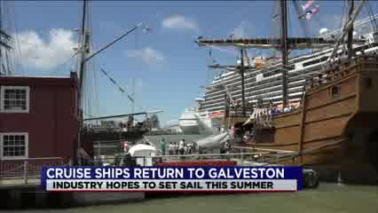Play | Carnival Breeze on CW 39 - Houston, TX  ABC13 Eyewitness News at 9pm on CW39  5/3/2021 12:32:47 AM  year. crowds came to welcome back carnival breeze in vista. they will stay in galveston until they are ready to welcome passengers. t.j.

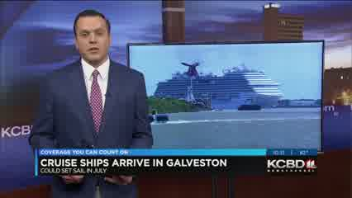Play | Carnival Cruise on KCBD (NBC) - Lubbock, TX  KCBD 11 at Ten  5/3/2021 1:31:18 AM  to celebrate the return of the carnival cruise line to its port. on its facebook page, the cruise line wrote quote

Play | Carnival Cruise on WDIV-DET (NBC) - Detroit, MI  Local 4 News  5/3/2021 1:32:35 AM  and they say the shortage might not get better anytime soon. >>> two carnival cruise ships returned to texas after a year hiatus due to coronavirus about a crowd gathered to silver the return of the colonel breeze and

Play | Carnival Cruise on Estrella TV KRCA 62 - Los Angeles, CA  Don Cheto  5/3/2021 1:52:18 AM  disfrutarán de un excelente fin de semana a bordo de carnival cruise line, destino final, los cabos, méxico gastos pagados por el hombre del vozarrón, don cheto. qué rico.

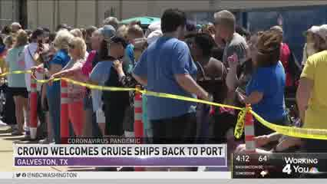Play | Carnival Cruise on WRC-DC (NBC) - Washington, D.C.  News4 Today at 4:00  5/3/2021 4:12:28 AM  a crowd gathered in galveston yesterday to welcome home the carnival cruise line to the port. cruises had been cancelled because of the pandemic and now more people are getting

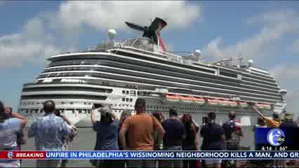Play | Carnival Cruise on WPVI-PHI (ABC) - Philadelphia, PA  Action News at 4:00 AM  5/3/2021 4:14:35 AM  >>> there is new hope for travel industry. two carnival cruise ships returned to the port of galveston in texas yesterday. people in the community along the gulf of mexico celebrated

Play | Carnival Cruise on KNBC-LA (NBC) - Los Angeles, CA  Today in LA at 4am  5/3/2021 4:16:24 AM  well. >>> another sign of hope, carnival cruise ships are back in valgalveston, texas. a crowd gathered to celebrate the return of the carnival breeze and carnival vista sterday.

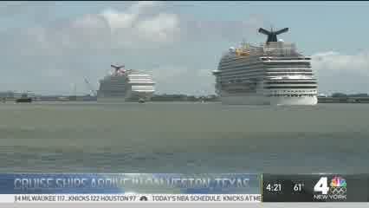Play | Carnival Cruise on WNBC-NY (NBC) - New York, NY  Today in New York  5/3/2021 4:21:28 AM  visitors have to wear masks and socially distance. >>> two carnival cruise ships return to galveston, texas. a crowd gathered to welcome home the ships. the cruise line wrote, we are so

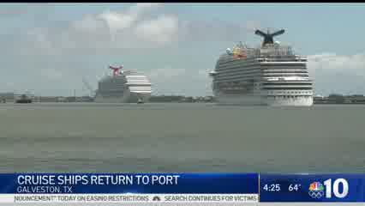Play | Carnival Cruise on WCAU-PHI (NBC) - Philadelphia, PA  NBC10 News Today at 4:00am  5/3/2021 4:25:12 AM  weekend. a crowd showed up to watch the return of the carnival cruise line to the port in galveston. the carnival breeze and vista have been docked since the pandemic started.

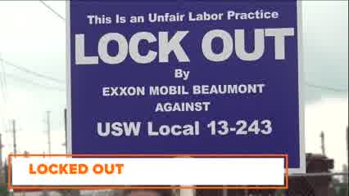Play | Carnival Cruise on KJAC (NBC) - Beaumont, TX  12 News Daybreak  5/3/2021 4:30:37 AM  workers union. ready to set sail? galveston welcoming two carnival cruise ships this weekend. the soonest you'll be able to hop on board. show open

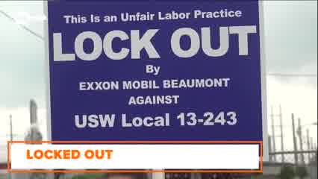Play | Carnival Cruise on KBMT (ABC) - Beaumont, TX  12 News Daybreak  5/3/2021 4:30:37 AM  workers union. ready to set sail? galveston welcoming two carnival cruise ships this weekend. the soonest you'll be able to hop on board. show open

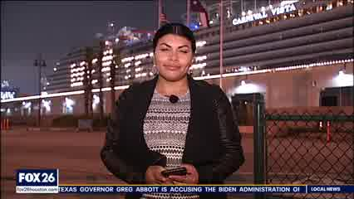Play | carnival cruises on KRIV-HOU (FOX) - Houston, TX  Wake Up! With SallyMac & Lina 4am  5/3/2021 4:33:49 AM  galveston along with federal maritime commission and carnival cruises, will be holding a press conference here today. just about how those operations are gonna work when they roll out in about two

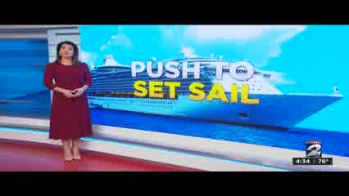Play | Carnival Cruise on KPRC-HOU (NBC) - Houston, TX  KPRC Channel 2 News Today 4:30 AM  5/3/2021 4:35:11 AM  cruise industry in galveston continues today. this afternoon. carnival cruise and several local leaders held a press conference urging the cdc to lift the ban on cruise traveling yesterday.

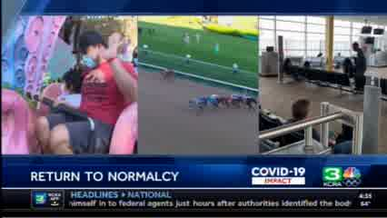Play | Carnival Cruise on KCRA-SAC (NBC) - Sacramento, CA  KCRA 3 Reports @ 4:30 AM  5/3/2021 4:35:56 AM  to galveston, texas for the first time in 14 months. dozens welcomed the carnival cruise ship as it headed into the port. >> i'm very excited, i love cruising.

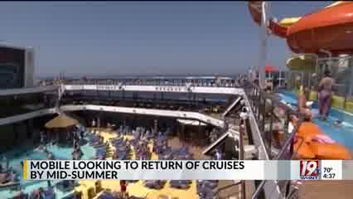Play | Carnival Cruise Lines on WHNT (CBS) - Huntsville, AL  WHNT News 19 Early Morning  5/3/2021 4:38:08 AM  certain benchmarks to resume operating around the july. officials are hopeful carnival cruise lines can resume trips from mobile area tourism agency says cruz's account for a 150 million dollars annually

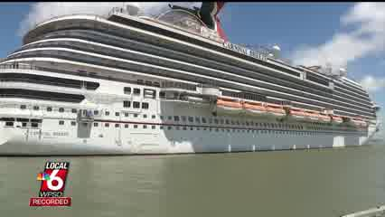Play | Carnival Cruise on WPSD (NBC) - Paducah, KY  WPSD Local 6 at 10:00  5/3/2021 4:39:02 AM  a crowd gathered to celebrate the return of the carnival cruise line to its port. on its facebook page, the cruise line wrote quote "we are so excited to finally have our

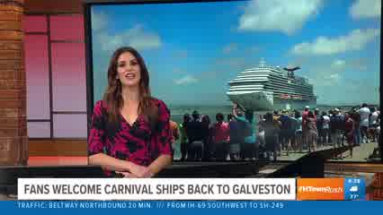Play | Carnival Cruise on KHOU-HOU (CBS) - Houston, TX  KHOU 11 News First Look  5/3/2021 4:39:05 AM  locations, text 713-526-1111 and we'll send a link to your phone. >> two carnival cruise you ships return to galveston. if you plan to hop aboard, covid shots will be required. we are waiting to learn how soon

Play | Carnival Cruise on WCMH-CBO (NBC) - Columbus, OH  NBC 4 Today  5/3/2021 4:44:15 AM  a crowd gathered in galveston, texas to celebrate the return of the carnival cruise line to its port. on its facebook page, the cruise line wrote quote --

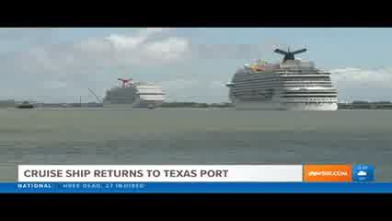Play | Carnival Cruise on WBIR (NBC) - Knoxville, TN  10 News First at 4:30  5/3/2021 4:48:12 AM  in galveston, texas gather to celebrate the return of the carnival cruise line to its port. the carnival breeze and carnival vista took a hiatus due to the covid 19 pandemic,

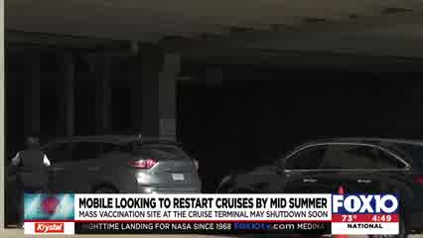Play | Carnival Cruise on WALA (FOX) - Mobile, AL  Fox 10 News @ 4:30AM  5/3/2021 4:49:35 AM  cruise terminal. officials say they are hopeful that carnival cruise lines can resume its trips from mobile. the area tourism agency says cruises account for 150 million annually, and

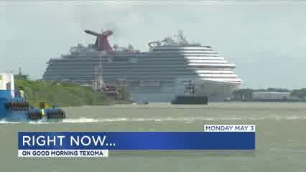Play | Carnival Cruise on KTEN (NBC) - Sherman, TX  KTEN News at 5AM  5/3/2021 5:00:28 AM  texas welcomed home two carnival cruise ships as they returned to their ports.. hello i'm bailey

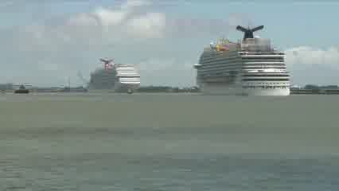Play | Carnival Cruise on KTEN (NBC) - Sherman, TX  KTEN News at 5AM  5/3/2021 5:06:11 AM  celebrate the return of the carnival cruise line to its port. on its facebook page, the cruise line

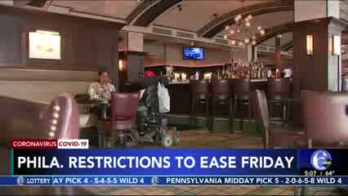Play | Carnival Cruise on WPVI-PHI (ABC) - Philadelphia, PA  Action News at 5:00 AM  5/3/2021 5:07:56 AM  people. >>> there is new hope for travel industry, two carnival cruise ship were back at galveston port yesterday. people in the community along the gulf of mexico celebrated

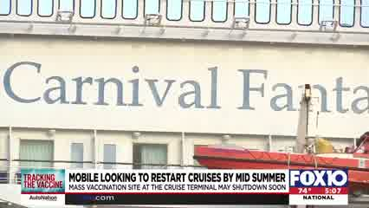Play | Carnival Cruise on WALA (FOX) - Mobile, AL  Fox 10 News at 5am  5/3/2021 5:08:01 AM  officials say they are hopeful that carnival cruise lines can resume its trips from mobile. the area tourism agency says cruises account for 150 million annually, and the covid- related

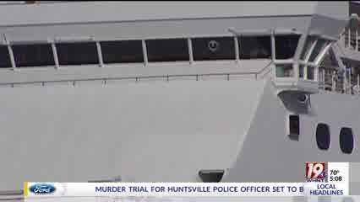Play | Carnival Cruise on WHNT (CBS) - Huntsville, AL  WHNT News 19 This Morning  5/3/2021 5:08:57 AM  certain benchmarks to resume operating around mid july. officials are hopeful carnival cruise lines can resume its troops from a bill. the area tourism agency says cruz's account for 150 million

Play | Carnival Cruise on WRC-DC (NBC) - Washington, D.C.  News4 Today at 5  5/3/2021 5:13:17 AM  a crowd gathered in galveston yesterday to welcome home the carnival cruise line to the port. cruises had been cancelled because of the pandemic and now more people are getting

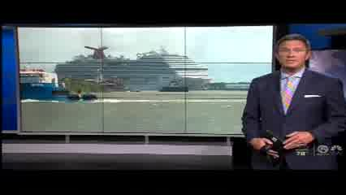Play | Carnival Cruise on WPTV (NBC) - West Palm Beach, FL  Today on 5 at 5  5/3/2021 5:15:26 AM  u-s ports. in galveston, texas -- a crowd gathered to watch two carnival cruise line shis return to port. the company says quote "we are so excited to finally have our ships back home." they say trips from

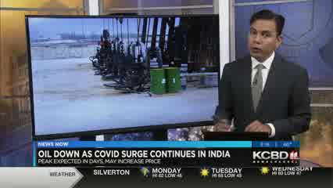Play | Carnival Cruise on KCBD (NBC) - Lubbock, TX  Early Daybreak  5/3/2021 5:16:54 AM  to celebrate the return of the carnival cruise line to its port. on its facebook page, the cruise line wrote quote

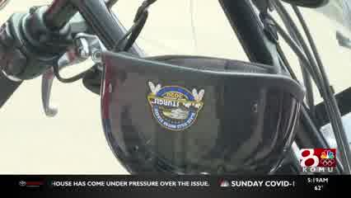Play | Carnival Cruise on KOMU (NBC) - Columbia, MO  KOMU News Today  5/3/2021 5:19:12 AM  were on board with the return of the carnival cruise line. the carnival breeze and carnival vista

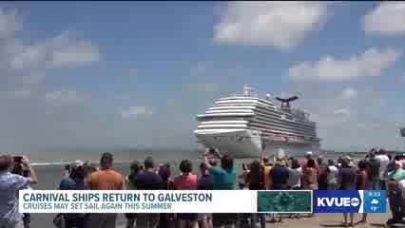Play | Carnival Cruise on KVUE-AUS (ABC) - Austin, TX  KVUE News Daybreak  5/3/2021 5:23:49 AM  time now is 5:xx. after more than a year-- two carnival cruise ships are back in galveston! the ships docked yesterday-- and were greeted by dozens of people.

Play | Carnival Cruise on KWES (NBC) - Odessa, TX  Newswest 9 Early Sunrise  5/3/2021 5:25:13 AM  two of its cruise ships. texans there are celebrating the return of the carnival cruise line to its port. the cruise line wrote on facebook that it's so excited to finally have our ships back

Play | Carnival Cruise on KPLC (NBC) - Lake Charles, LA  7 News Early Sunrise  5/3/2021 5:25:45 AM  ships in galveston. a crowd gathered to celebrate the return of the carnival cruise line to its port. on its facebook page, the cruise line wrote quote "we are so excited to finally have our ships back

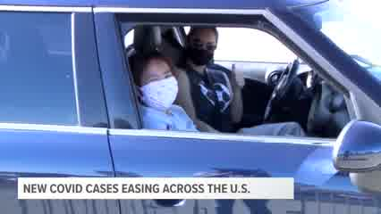Play | Carnival Cruise on KYTX (CBS) - Tyler, TX  The Morning Loop on CBS19 News  5/3/2021 5:25:56 AM  demand. hello texas two carnival cruise ships returned to the port of galveston in texas on sunday. after over a year away, the return of the ships offers a

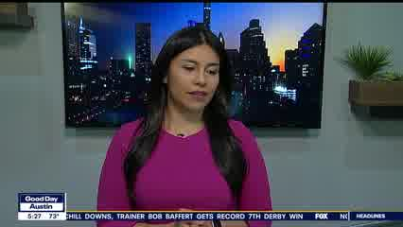Play | Carnival Cruise on KTBC-AUS (FOX) - Austin, TX  Good Day Austin  5/3/2021 5:26:55 AM  hee reporting. later today, the federal maritime commission, carnival cruise executives, along with galveston officials will be hosting a news conference to discuss the return of

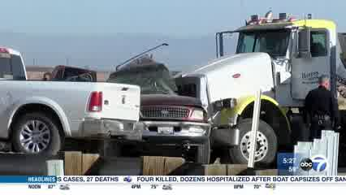Play | Carnival Cruise on WLS-CHI (ABC) - Chicago, IL  ABC 7 Eyewitness News @ 5A  5/3/2021 5:27:14 AM  a migrants were packed inside. abc news, new york many 5:27. two carnival cruise ships have returned to the port of galveston in texas. 23,000 jobs were lost in texas when the pandemic stopped

Play | Carnival Cruise on KSWO (ABC) - Wichita Falls, TX  Good Morning Texoma at 5:30A  5/3/2021 5:30:51 AM  authorization will help combat the slowing vaccine numbers. haley yesterday, carnival cruise ships arrived in galveston, texas. while it may not mean that passengers can resume vacationing

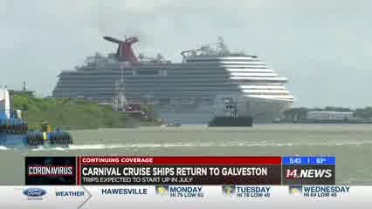Play | Carnival Cruise on WFIE (NBC) - Evansville, IN  14 News at Sunrise  5/3/2021 5:43:14 AM  two of its cruise ships.a crowd celebrated the return of the carnival cruise line to its port. on its facebook page, the cruise line wrote quote "we are so excited

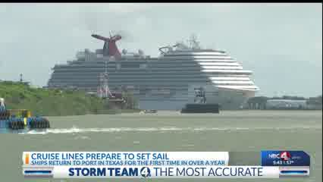Play | Carnival Cruise on WCMH-CBO (NBC) - Columbus, OH  NBC 4 Today at 5am  5/3/2021 5:43:37 AM  texas to celebrate the return of the carnival cruise line to its port. on its facebook page, the cruise line wrote quote --

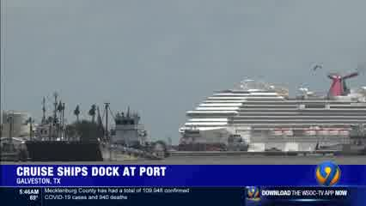Play | Carnival Cruise on WSOC-CLT (ABC) - Charlotte, NC  Eyewitness News Daybreak 5:00A  5/3/2021 5:46:44 AM  long time. yeah. look at galveston, texas yesterday. these carnival cruise ships returned. >> you hear the cheers there from dozens of people excited to see the big inching toward

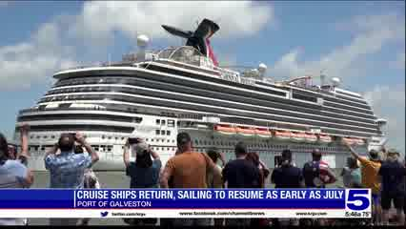Play | Carnival Cruise on KRGV (ABC) - Harlingen, TX  Channel 5 News This Morning at 5:30AM  5/3/2021 5:47:15 AM  yesterday... a couple of carnival cruise ships arrived at the port of galveston... providing some hope for the cruise

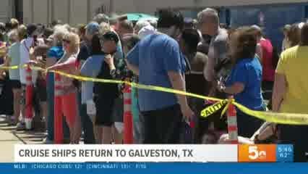Play | Carnival Cruise on KSDK-STL (NBC) - St. Louis, MO  Today in St. Louis  5/3/2021 5:47:18 AM  be excited to see this. galveston, texas welcomed home to carnival cruise ships. a crowd gathered to celebrate the return. the carnival website says trips from galveston will resume in

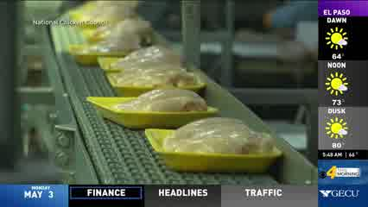Play | Carnival Cruise on KDBC (CBS) - El Paso, TX  CBS4 This Morning-5AM  5/3/2021 5:48:50 AM  soon catch up with demand. texas ranks highly for dog bite insurance claims and carnival cruise ships return to texas ports for the 1st time in over a year dean king is any york with those stories and more in

Play | Carnival Cruise on CBS 4 Valley Central - Harlingen, TX  5/3/2021 5:49:04 AM  toss: texas ranks high for dog bite insurance claims. and carnival cruise ships return to a texas port for the first time in over a year. jane king is in new york with those stories and more in todays

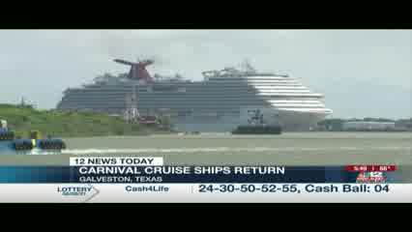Play | Carnival Cruise on WWBT-RIC (NBC) - Richmond, VA  12 News at 5:30 AM  5/3/2021 5:49:59 AM  galveston, texas. crowd gathered to celebrate the return of the carnival cruise line to its ports, the carnival breeze and carnival vista took a hiatus because of the pandemic, and, according to the

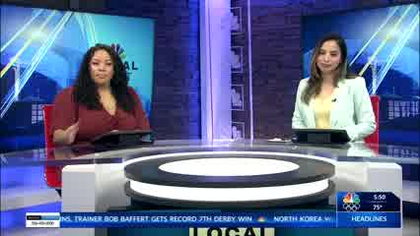Play | Carnival Cruise on KVEO (NBC) - Harlingen, TX  Local 23 News Today  5/3/2021 5:51:05 AM  cruise ships. a crowd gathered to celebrate the return of the carnival cruise line to its port. on the cruise's facebook was posted a message saying "we are so excited to finally have our ships back home." the

Play | Carnival Cruise on KIDK (CBS) - Idaho Falls, ID  Copper Chef Titan  5/3/2021 5:55:40 AM  some cruise ships are sailing the open seas again. there was cheering as carnival cruise lines docked in their port in texas. it's been 14 months since passenger cruise ships have

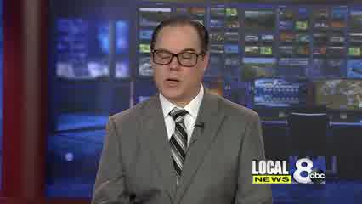Play | Carnival Cruise on KIFI (ABC) - Idaho Falls, ID  Local News 8 This Morning  5/3/2021 5:55:41 AM  some cruise ships are sailing the open seas again. there was cheering as carnival cruise lines docked in their port in texas. it's been 14 months since passenger cruise ships have

Play | Carnival Cruise on WABC-AM (ABC) - New York, NY  5/3/2021 5:55:56 AM  boat OK. All right. In a sign of potentially the cruise industry gearing up to Carnival cruise lines ship berthed in the port of Galveston in Texas on Sunday. This is the time this has happened in more than a year as the industry looks to re-start after being obviously devastated by the coveted pandemic the Carnival

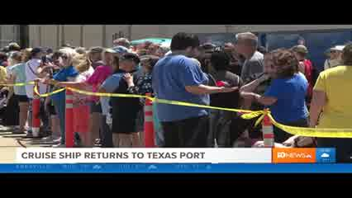Play | Carnival Cruise on WBIR (NBC) - Knoxville, TN  10 News Daybreak  5/3/2021 5:57:16 AM  crowds in galveston, texas gathered to celebrate the return of the carnival cruise line to its port. the carnival breeze and carnival vista took a hiatus during the pandemic, according

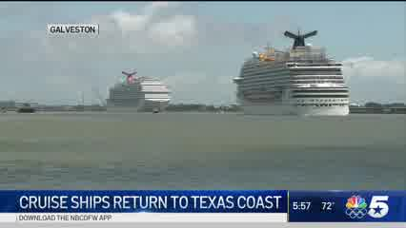Play | Carnival Cruise on KXAS-DAL (NBC) - Dallas, TX  NBC 5 Today at 5:30  5/3/2021 5:57:37 AM  a crowd gathered to celebrate the return of the carnival cruise line over the weekend. on the facebook page, the cruise line wrote we're excited to have our trips back

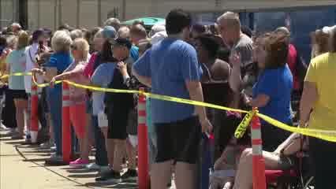Play | Carnival Cruise on KTEN-DT3 - Sherman, TX  Good Morning Texoma at 5:30A  5/3/2021 6:03:20 AM  celebrate the return of the carnival cruise line to its port. on its facebook page, the cruise line

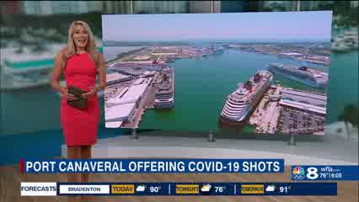Play | Carnival Cruise on Great 38 (WTTA) - Tampa Bay, FL  Newschannel 8 Today @ 6AM  5/3/2021 6:05:16 AM  cruise industry is getting ready to resume sailing. 2 carnival cruise ships returned to the port of galveston for the first time in more than a year. the ship spent the last year on hiatus because of the

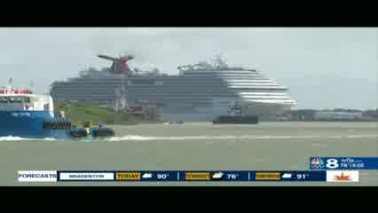Play | Carnival Cruise on WFLA-TB (NBC) - Tampa Bay, FL  News Ch8 Today at 6AM  5/3/2021 6:05:23 AM  cruise industry is getting ready to resume sailing. 2 carnival cruise ships returned to the port of galveston for the first time in more than a year. the ship spent the last year on hiatus because of the

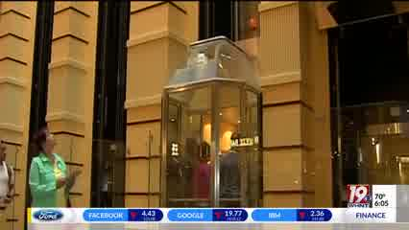Play | Carnival Cruise on WHNT (CBS) - Huntsville, AL  WHNT News 19 This Morning  5/3/2021 6:05:52 AM  almost all of their staff fully vaccinated officials hope crook carnival cruise lines can resume its troops from appeal. the area tourism agency says cruz's account for 150 million dollars annually

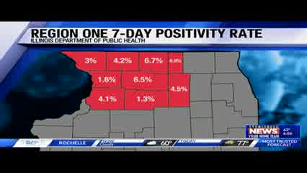Play | Carnival Cruise on WTVO (ABC) - Rockford, IL  Eyewitness News More Local at 6AM  5/3/2021 6:06:54 AM  ((elliot)) more progress for the travel industry this morning-- two carnival cruise ships are back at their port after more than a year away. the ships still aren't allowed to board passengers from the

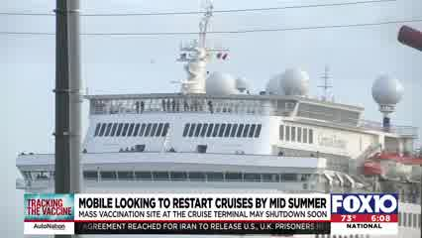Play | Carnival Cruise on WALA (FOX) - Mobile, AL  FOX 10 News at 6:00 AM  5/3/2021 6:08:23 AM  officials say they are hopeful that carnival cruise lines can resume its trips from mobile. the area tourism agency says cruises account for 150 million annually, and the covid- related

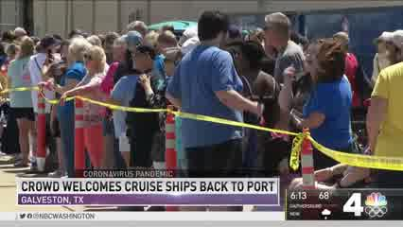Play | Carnival Cruise on WRC-DC (NBC) - Washington, D.C.  News4 Today at 6  5/3/2021 6:13:48 AM  a crowd gathered in galveston yesterday to welcome home the carnival cruise line to the port. cruises had been cancelled because of the pandemic and now more people are getting

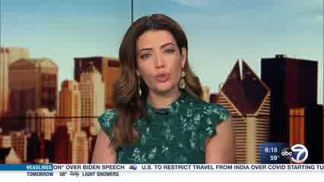Play | Carnival Cruise on WLS-CHI (ABC) - Chicago, IL  ABC 7 Eyewitness News @ 6A  5/3/2021 6:15:21 AM  at least 22 others managed to reach the shore on their own. two carnival cruise ships have returned to the port of galveston in texas. 23,000 jobs and $1.6 billion in wages were lost in texas during

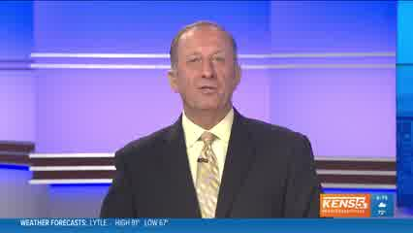Play | Carnival Cruise on KENS-SAT (CBS) - San Antonio, TX  Eyewitness News at 6AM  5/3/2021 6:15:30 AM  families. well, here's something that'll make you smile to carnival cruise ships get a warm welcome . they return to port in galveston for the first time in

Play | Carnival Cruise on KCBD (NBC) - Lubbock, TX  Daybreak Today  5/3/2021 6:16:11 AM  to celebrate the return of the carnival cruise line to its port. on its facebook page, the cruise line wrote quote

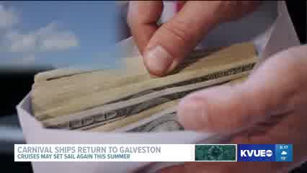Play | Carnival Cruise on KVUE-AUS (ABC) - Austin, TX  KVUE News Daybreak  5/3/2021 6:17:38 AM  money-- starting this month. after more than a year-- two carnival cruise ships are back in galveston! the ships docked yesterday-- and were greeted by dozens of people.

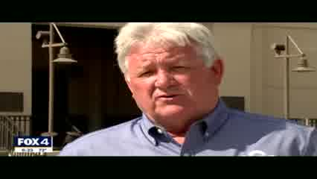Play | Carnival Cruise on KDFW-DAL (FOX) - Dallas, TX  Good Day at 6  5/3/2021 6:23:51 AM  mention the revenues but also the jobs. all to the executives with carnival cruise line, and the federal maritime commission will discuss the return of cruises to galveston. it feels like you want to eventually get

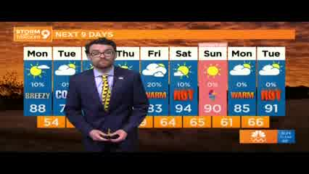Play | Carnival Cruise on KWES (NBC) - Odessa, TX  Newswest 9 Sunrise  5/3/2021 6:24:33 AM  ships. texans there are celebrating the return of the carnival cruise line to its port. the cruise line wrote on facebook that it's so excited to

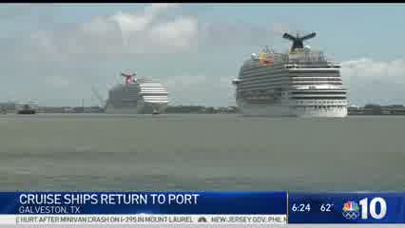Play | Carnival Cruise on WCAU-PHI (NBC) - Philadelphia, PA  NBC10 News Today at 6am  5/3/2021 6:24:40 AM  weekend. a crowd showed up to watch the return of the carnival cruise line to the port in galveston. the carnival breeze and vista have been docked since the pandemic started.

Play | Carnival Cruise on WBND (ABC) - South Bend, IN  ABC57 News at 6A  5/3/2021 6:25:23 AM  yesterday -- for the first time in over a year!two ships from carnival cruise line -- docked at galveston, texas -- after 14 months away. and now the c-d-c says as long as 95-percent of passengers and

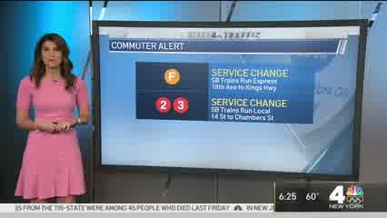Play | Carnival Cruise on WNBC-NY (NBC) - New York, NY  Today in New York  5/3/2021 6:26:00 AM  nassau county and queens commuters. >>> two carnival cruise ships returning to galveston, texas, after the hiatus that was forced on them. welcoming home "carnival breeze"

Play | Carnival Cruise on KVHPDT2 (ABC) - Lake Charles, LA  7News Sunrise  5/3/2021 6:26:02 AM  ships d gathered to celebrate the return of the carnival cruise line to face wrote quote "we are so excited finally have our ships back home." the

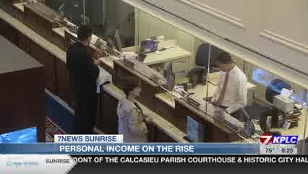Play | Carnival Cruise on KPLC (NBC) - Lake Charles, LA  7 News Sunrise  5/3/2021 6:26:02 AM  ships in galveston. a crowd gathered to celebrate the return of the carnival cruise line to its port. on its facebook page, the cruise line wrote quote "we are so excited to finally have our ships back

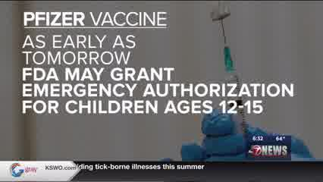Play | Carnival Cruise on KSWO (ABC) - Wichita Falls, TX  7 News: Good Morning Texoma  5/3/2021 6:32:14 AM  authorization will help combat the slowing vaccine numbers. haley yesterday, carnival cruise ships arrived in galveston, texas. while it may not mean that passengers can resume vacationing

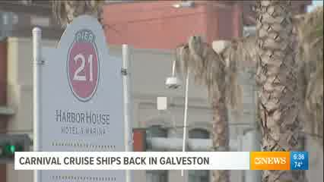Play | Carnival Cruise on KIII (ABC) - Corpus Christi, TX  3 News---First Edition  5/3/2021 6:36:00 AM  one year. cruise ships are back in our state to carnival cruise lines pulled up into the port of galveston and docked along the harbor side yesterday for the first time since april 20

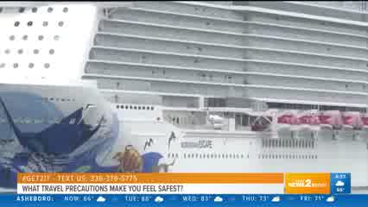Play | Carnival Cruise on WFMY (CBS) - Greensboro, NC  Good Morning Show  5/3/2021 6:37:50 AM  members are vaccinated against covid-19 this news prompting two carnival cruise ships to dock in galveston sunday the first time boats have been there in more than a year. i >> think that requirements

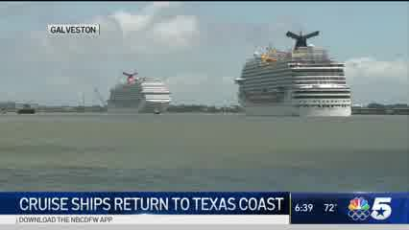Play | Carnival Cruise on KXAS-DAL (NBC) - Dallas, TX  NBC 5 Today at 6  5/3/2021 6:39:22 AM  cruise ships gathered to celebrate the return of the carnival cruise line over the weekend. on the facebook page, the cruise line wrote, we're so excited to have our ships

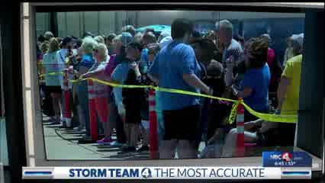Play | Carnival Cruise on WCMH-CBO (NBC) - Columbus, OH  NBC 4 Today at 6am  5/3/2021 6:45:09 AM  matt: a crowd gathered to celebrate the return of the carnival cruise line to its port. on its facebook page, the cruise line wrote quote "we are so excited to finally have our ships back

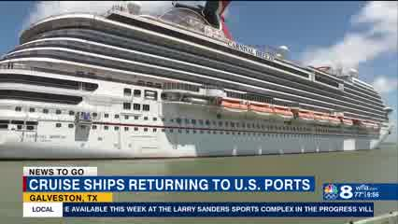Play | Carnival Cruise on Great 38 (WTTA) - Tampa Bay, FL  Newschannel 8 Today @ 6AM  5/3/2021 6:56:08 AM  than a year cruise ships are making their way back to port in galveston 2 carnival cruise ships arrived this weekend. it comes as the cdc gave cruise lines the green light to resume operations in mid july.

Play | Carnival Cruise on WFLA-TB (NBC) - Tampa Bay, FL  News Ch8 Today at 6AM  5/3/2021 6:56:14 AM  than a year cruise ships are making their way back to port in galveston 2 carnival cruise ships arrived this weekend. it comes as the cdc gave cruise lines the green light to resume operations in mid july.

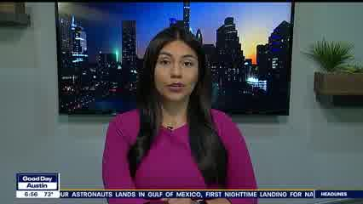Play | Carnival Cruise on KTBC-AUS (FOX) - Austin, TX  Good Day Austin  5/3/2021 6:56:40 AM  jobs statewide. later today, the federal maritime commission, carnival cruise executives, and galveston officials will host a news conference to talk about the return of cruises in

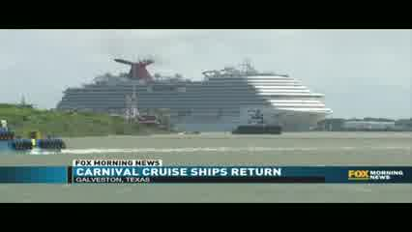Play | Carnival Cruise on WRLH-RIC (FOX) - Richmond, VA  Fox Richmond Morning News  5/3/2021 7:47:17 AM  a crowd gathered to celebrate the return of the carnival cruise line to its port. the carnival breeze and carnival vista took a hiatus because of the

