**Community Drive-thru Food Distribution- Miscellaneous**

AAPA 2020 Communications Awards Program, Classification 6- Miscellaneous

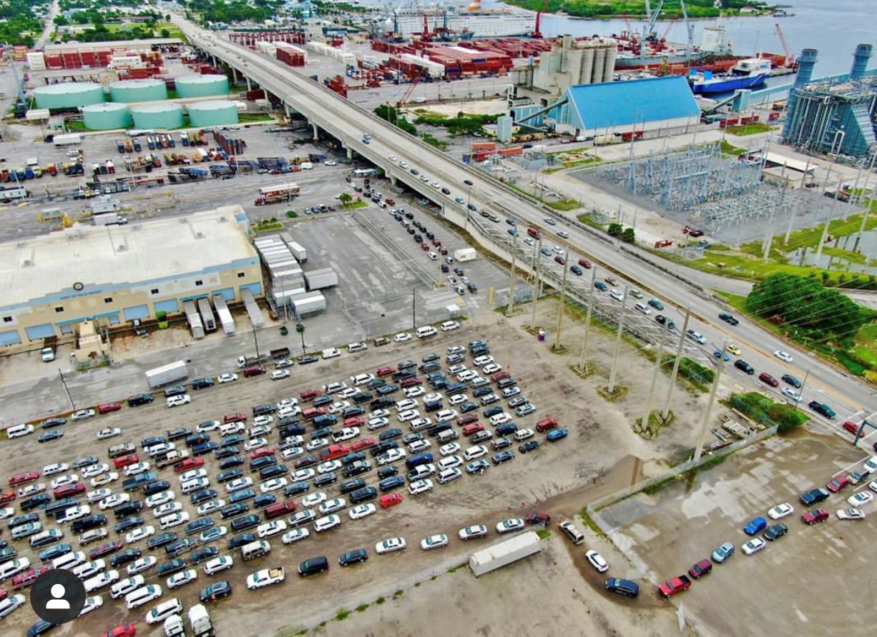

**Summary:**

The COVID-19 pandemic caused a significant economic downturn in South Florida communities, with more than 227,000 people filing for unemployment in Florida back in late March 2020. In response to the loss of jobs and businesses in our area, the Port of Palm Beach teamed up with [**Hospitality Helping Hands**](https://www.hospitalityhelpinghands.org/)and community partners to host a weekly drive-thru food distribution at the port.

May 30th of this year marked one year since the Port began providing space, security staff and trash pickup for the weekly distribution event. To date, more than 50,000 people have received groceries, baby supplies and pet products on Port property. These weekly events allowed the Port to show our commitment to our communities.

# **COMMUNICATION CHALLENGES OR OPPORtunities**

**CHALLENGES:**

* Location and commencement of weekly event – We had to find a simple way to show visitors where on Port property, the event was being held. This was especially important since some individuals were coming from outside our neighboring communities. We created a map detailing how to get on site. The map was distributed to the groups’ involved, local media, tenants, stakeholders, published on our website and shared on all social media platforms. The Port’s PIO distributed a [news release](https://www.portofpalmbeach.com/DocumentCenter/View/2554/Port-of-Palm-Beach-news-release) and a [video](https://www.youtube.com/watch?time_continue=5&v=M6VhDsohTWk&feature=emb_title) showing the location of the food drive, to media contacts ahead of the event.

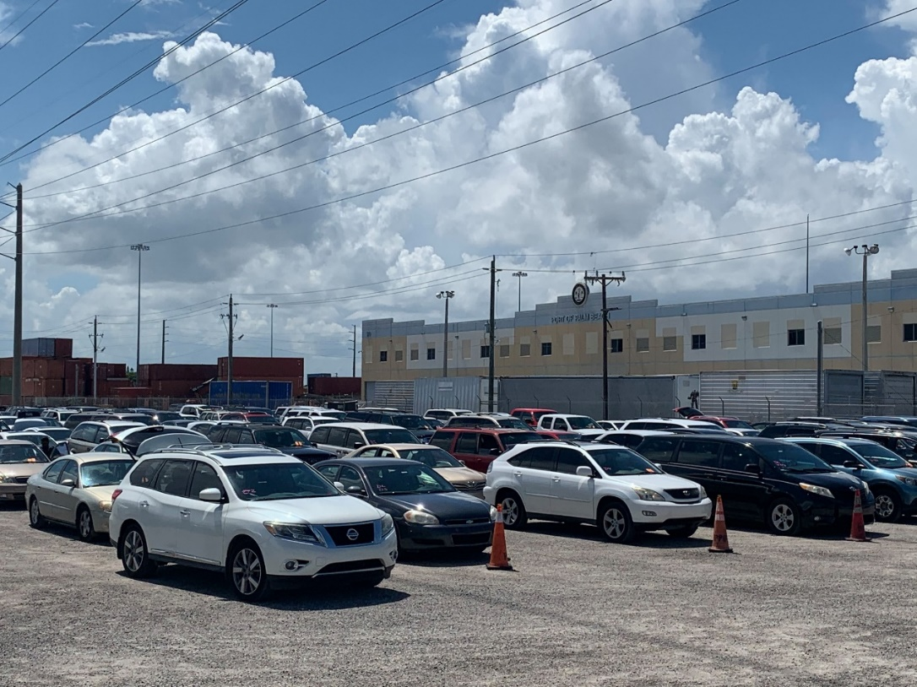 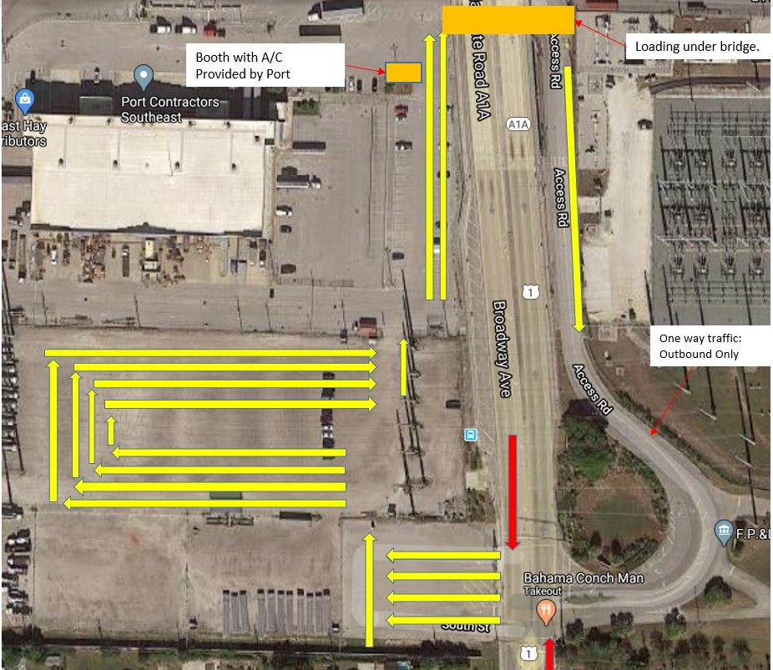

* Hurricane Isaias- The USCG set Port Condition Zulu on Saturday, August 1, 2020, which meant the Port would close until further notice. The Port’s PIO notified Hospitality Helping Hands about the closure. The organization had a difficult time understanding our position, since they do not know first-hand all the time and work that goes into to preparing our seaport for a hurricane. Notifications were posted on our website and social media pages the day before the event was scheduled to take place. We also contacted the media to add the closure to their hurricane coverage.



* Change of location- In the early months of 2021, Florida Power and Light, was in need of the annex property (location of food drive) for vehicles and materials needed to support a tunnel intake project. The Port had no choice but to relocate the food drive. We conducted two walk-throughs with Hospitality Helping Hands to ensure a smooth transition. We provided them with a new map with directions to avoid visitors showing up at the previous location. The Port’s PIO notified the local media to help spread the word.

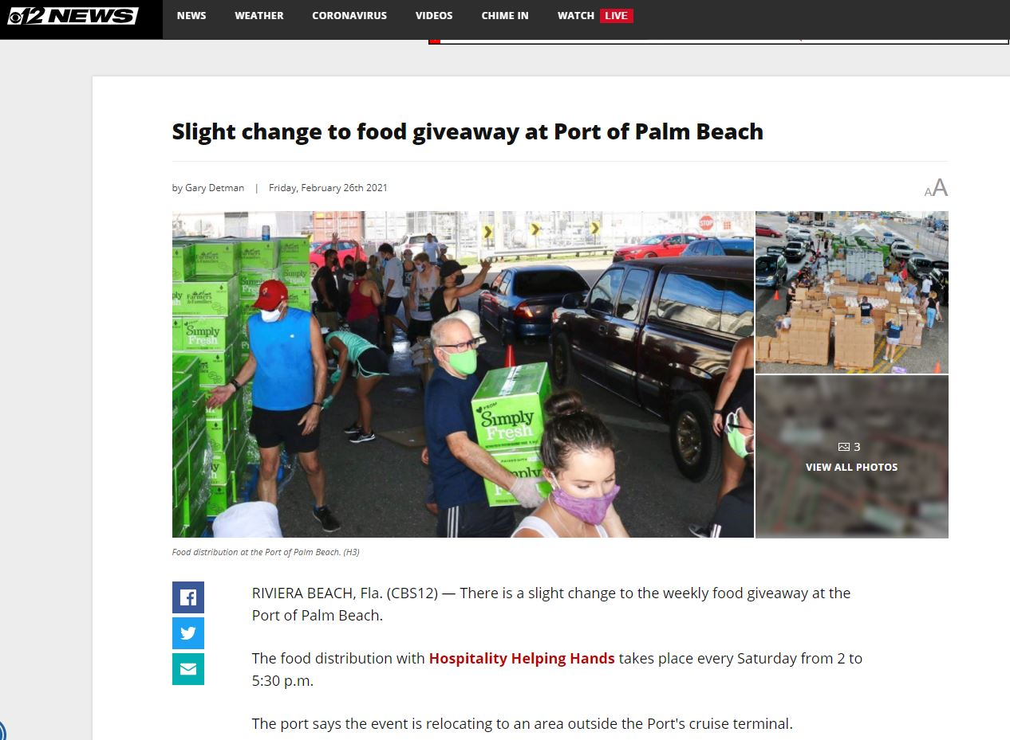 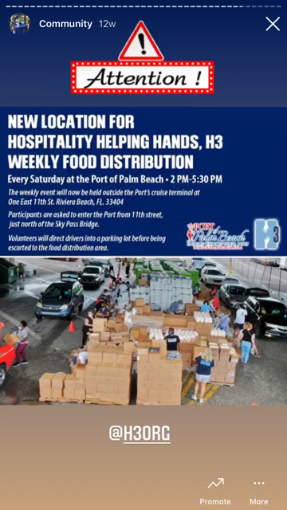

In an effort to reach a larger group of people, the Port’s PIO created a series of stories on Instagram and Facebook show the new location. The stories were shared on Hospitality Helpings Hands Instagram page.



**OPPORTUNITIES:**

* Serving the public- Hosting the weekly food drive at the Port of Palm Beach allowed us to showcase our commitment to the people living around the Port. The events also allowed us to engage with the public, as many of our Port staff members and Commissioners volunteered at some of the events.
* Building partnerships with community partners- It took a village to successfully hosts the weekly food distribution events at the Port. Throughout the year, there were at least 10 organizations that came together to offer free food, baby supplies and pet products to families in need of assistance during the CODI-19 pandemic.
  + Hospitality Helping Hands
  + Living Hungry
  + Palm Beach Harvest
  + Feeding South Florida
  + Palm Beach Food Bank
  + United Farmers Alliance
  + Peggy Adams
  + Miami Diaper Bank

This particular project allowed us to build long lasting relationships with the organizations. The Port’s PIO also worked with the local municipality, City of Riviera Beach, to promote the food drives in their digital newsletters.

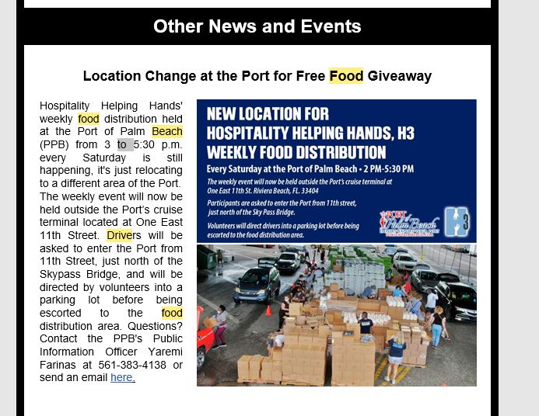

Increased awareness of Port Security- Our Port Security team worked overtime for several weeks to ensure the distribution events were safe and fluid. Their presence gave us the opportunity to put our officer’s front and center where they could intermingle with the volunteers and families receiving food. Port Security Sgt. Jeff Farr even allowed a young girl to help him direct traffic after weeks of seeing her and her family. 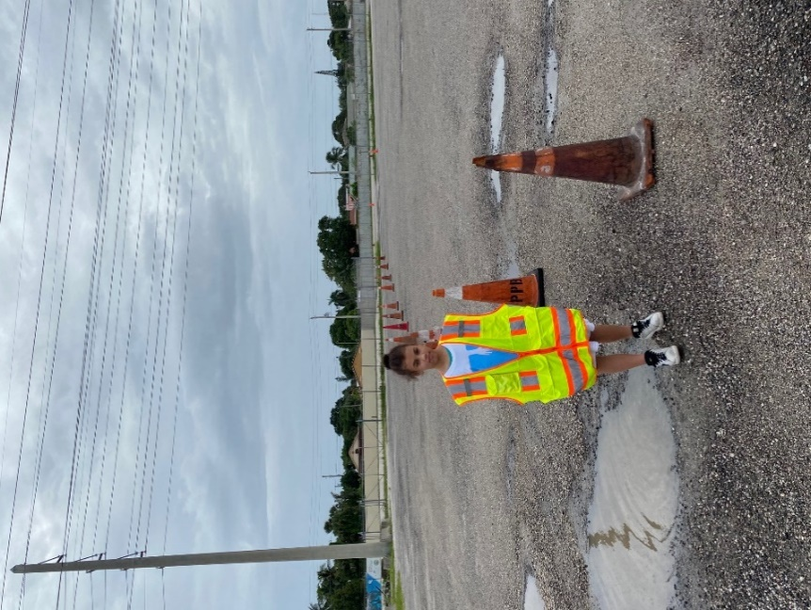

* Media Coverage and in-house production videos- The grocery distribution tremendously increased the Port’s exposure. The news coverage displayed the Port and its tenants in a positive light. The media coverage also benefited the organizations involved who were in need of donations and volunteers. People are more likely to donate to an effort when they see the outcome. Media coverage was critical in making that happen.

According to our Meltwater reports, local news stories reached more than 1 million people. Over the course of a year, there were more than 30 news stories and or publications showcasing the food drive events at the Port. Below are just a few:

* [**Watch local NBC station news story**](https://www.wptv.com/news/region-c-palm-beach-county/riviera-beach/free-drive-through-food-distribution-held-at-the-port-of-palm-beach)
* [**Watch local Fox station news story**](https://www.wflx.com/2020/05/30/food-distribution-held-port-palm-beach/)
* [**Read Florida Ports Council’s news update**](https://flaports.org/2020/06/17/free-drive-thru-food-distribution-at-port-of-palm-beach/)
* [**Read Palm Beach Post article**](https://www.palmbeachpost.com/story/news/local/2020/12/22/free-food-food-pantry-near-me-distribution-sites-palm-beach-county/3997313001/)
* [**Featured in AAPA Seaports Magazine article “A Helping Hand”**](https://www.aapaseaports.com/index.php/2020/10/08/a-helping-hand/)

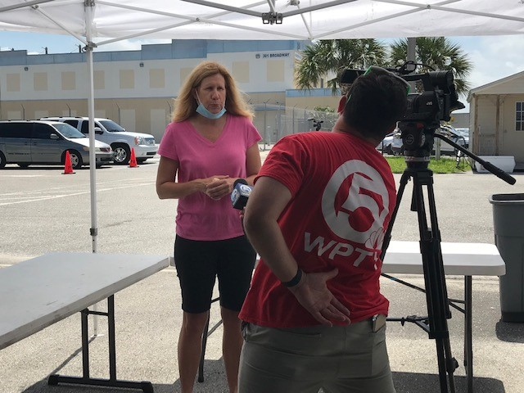

In addition to the news coverage, the Port’s PIO and Director of Planning and Development worked together to produce three food drive videos to showcase the work being done by volunteers at the Port.

[**Watch Port video from day before event**](https://www.youtube.com/watch?v=M6VhDsohTWk&t=5s)**-** More than 600 views on YouTube and social media platforms

[**Watch Port video from May 30, 2020 event**](https://www.youtube.com/watch?v=Oxz1hcdu5HA&t=3s)**-** More than 800 views on YouTube and social media platforms

[**Watch Port video from February 27, 2021 event**](https://www.youtube.com/watch?v=ABr4CybS18g) **–** More than 500 views on YouTube and social media platforms

1. **Complementing the Overall Mission**

The community food distribution event complements the Port of Palm Beach’s mission to serve as a pillar for the local community. One of our Commissioners proposed the idea of providing the space and Port staff decided it was our duty to step in and assist during the unprecedented time. While the space did not cost us anything, the Port did spend thousands of dollars in overtime for Port security to work the events, about $5,000 in dumpster pickup charges and countless hours of communication efforts. The expenses were well worth it to the Port and shows the community while we operate as a business, we are here to serve them. Part of being a pillar for the local community is continuing to expand our communication with citizens. The food drive allowed us to just that.

1. **Planning and Programming Components**

This project involved quick planning due to the fluid situation with COVID-19 and Hospitality Helping Hands needing a location immediately. Port Commissioner Katherine Waldron requested approval from the Board to support the food distribution during the 2020 May Board meeting. Once the Board approved using the Port as a food distribution site, our Port operations and communications teams immediately begin working with the entities involved to create a plan of action. Our goal was to show the community the Port of Palm Beach cared about their well-being, while at the same time, keeping the port operational during the COVID-19 pandemic. The Port’s PIO contacted the parties involved to discuss news coverage and how to work together to promote the events. Since this was a continuous event, the communications strategies varied throughout the year.

1. **Actions and Outputs**

* Communicate with tenants to avoid a disruption to Port operations
* Communication with organizations involved to ensure volunteers were aware of where to park
* Distributed a news release prior to first food distribution event
* Created in-house video to show event site
* Coordinated interviews with Port Commisisoners and community partners at the May 30th event
* Published reminders of the event on Port website and social media pages
* Weekly messages notifying Port staff, Commissioners and tenants about the event. It was crucial for the Port family to know exactly what was going on at the Port on the days of the event. This would help avoid any disruption to port operations
* Provided maps, updates and time changes to the media and parties involved
* Constant communication with Hospitality Helping Hands to ensure the correct information was being disseminated to the families attending the event, Port workers and the media
* Created graphics on numerous occasions to promote event
* Created video stories to share the efforts at the Port
* Monthly updates on our [**e-newsletters**](https://www.portofpalmbeach.com/list.aspx?PRVMSG=249)

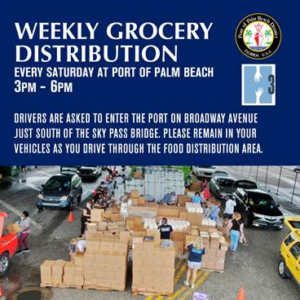 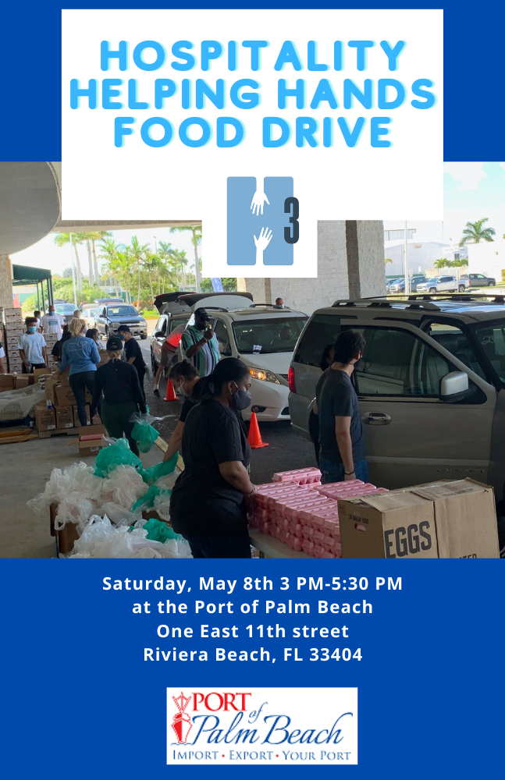

The first event was held On May 30, 2020, just nine days after the Port became involved. That event and the 52 other that followed were all successful and resulted with more than 50,000 people being fed. Overall, we believe our operational expertise, communication skills and messaging helped make the food drive a success.

1. **Communication Outcomes**

This weekly event was well received by the Hospitality Helping Hands who spearheaded the events, local organizations and the community.

Below are a few quotes and comments on social media that show appreciation for the Port and its partners.

“The Port has been one of H3’s greatest allies. From giving us a home to spreading the word, we are so happy to have partnered with the Port of Palm Beach for the past year. The communication with the Port staff has been next level. The administration, maintenance, and security teams have worked together flawlessly to ensure the show ran as smooth as possible. Not only helping us get the word out through their own channels but setting the stage for us to do what we do best, serve,” –**David Rae, Hospitality Helping Hands.**

“The clear communication between the Port of Palm Beach and my operations team enabled us to make informed decisions to maintain our regular weekend operations at the Southgate facility.  My operations manager found the weekly e-mail communication to be particularly useful in creating staff work schedules. It also allowed us to keep our customers satisfied and their animals fed. On the professional services side, our service providers were provided clear insight into available shipping and receiving hours, which ultimately allowed both Southeast Hay and the weekly grocery distribution initiative to operate efficiently and simultaneously in the same space,” – **Alexander Christensen, Port tenant Southeast Hay Distributors.**

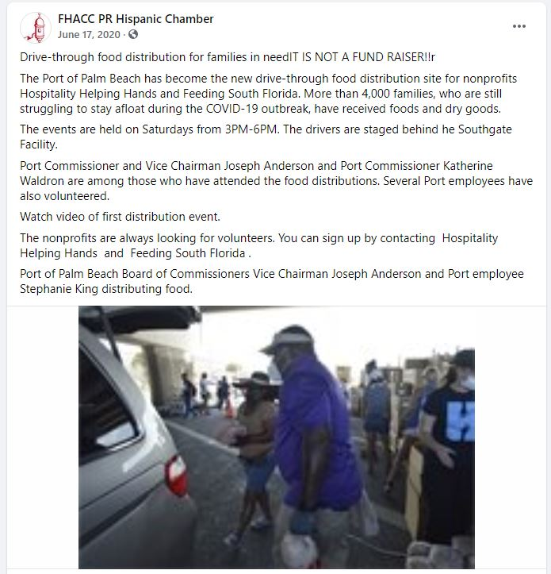

“They work so hard and put their heart and soul into this each week. You guys have so many wonderful and committed volunteers,” **-Nacu Bauman.**

“Awesome work,” **-YelpWestPalm**

“Thank you for helping others,” **–Brenda Tominovich**

“God bless each and every one,” **-Bessie Presnell**