Human Trafficking Awareness Campaign
AAPA 2020 Communications Awards Program, Classification 7- Overall Campaign
Summary: In January 2021, during National Slavery and Human Trafficking Prevention Month, the Port of Palm Beach offered port employees a virtual human trafficking awareness training, specifically catered for seaport workers. The Port of Palm Beach was the first seaport in Florida and the second in the country that adopted the “Ports to Freedom” training. This campaign took three months of planning with an organization called Businesses Ending Slavery and Human Trafficking. We took a multifaceted communication approach to successfully gain support from our Board of Commissioners, inform our employees of the training and educate the members of the community on the port’s commitment to safety.

COMMUNICATION CHALLENGES AND/OR OPPORtunities
In order for the Port to offer employees the “Ports to Freedom” virtual training, the Port’s PIO needed approval from the Board of Commissioners. The PIO spent two months preparing an agreement for the Board to review during the January Board Meeting. The Board unanimously approved the training and it was available to employees just four days later. It was crucial to get approval during the month of January so the training would run simultaneously during National Slavery and Human Trafficking Prevention Month. Another obstacle was ensuring all employees could log in for the training. This required close communication with the PIO, who would in turn contact the organization when employees received an error message.
The opportunities definitely outweighed the challenges in this particularly campaign.

- INCREASE IN EMPLOYEE PARTICIPATION- We had a total of 48 out of 54 employees complete the online training. This was by far the most attended non-mandatory training class offered to employees. The Port’s PIO worked closely with the Senior Director of Operations to schedule group training for those who did not have immediate access to a computer.

- SHOWCASE PORT SECURITY TEAM- The campaign provided us the opportunity to put our security team front and center. We wanted to show the tenants and community how their local port security team is constantly improving their safety skills. This was a perfect time to shed light on seaport safety operations and our commitment to stepping in when you see something that’s just not right.

- INCREASE PORT EXPOSURE - With local news outlets covering everything COVID, the Port’s PIO knew it would be a challenge to get reporters to physically go to the Port to cover the human trafficking awareness initiative. In an effort to increase the chances of media coverage, she decided to produce video interviews and video footage to provide to reporters. This gave the Port the ability to publicize the message we chose to share.

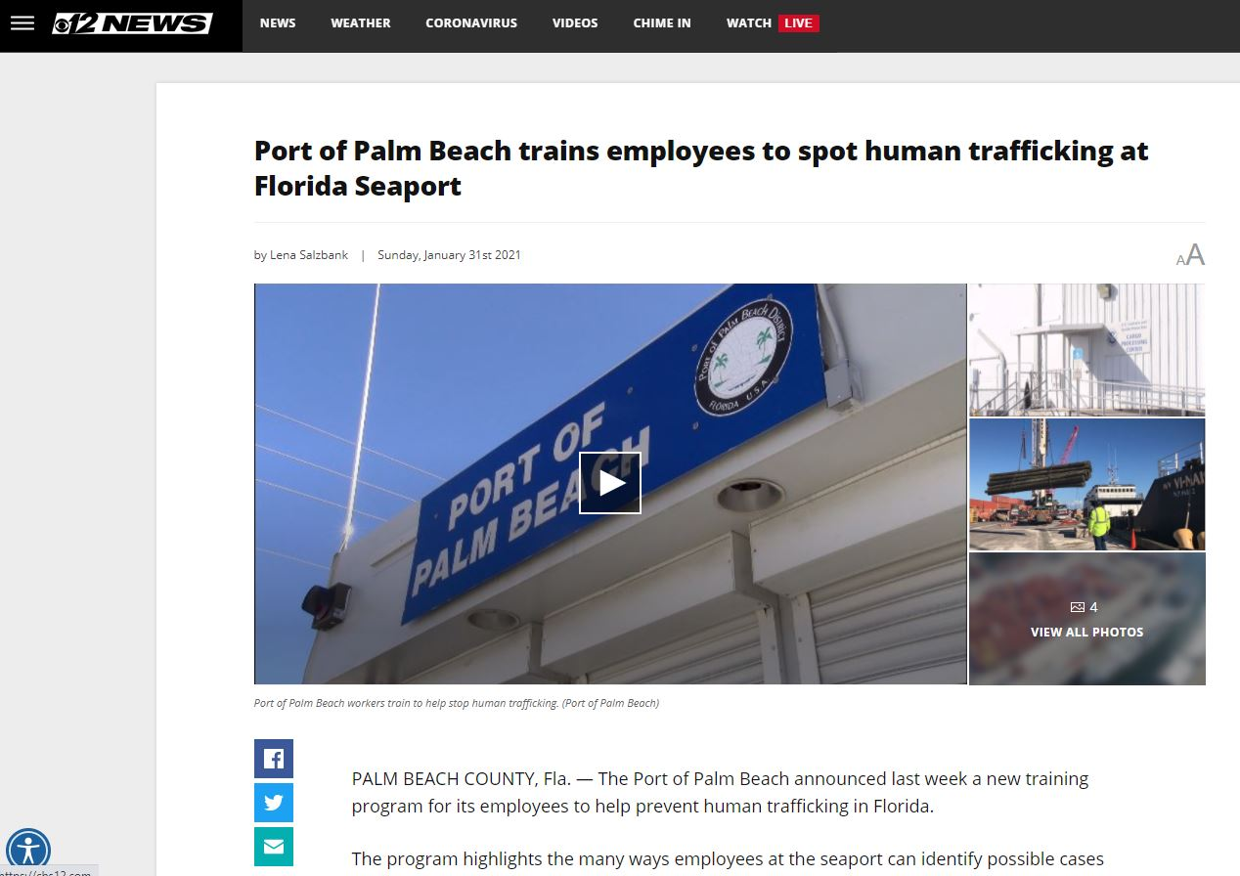

- Complementing the Overall Mission

Port of Palm Beach’s mission is to sustain world-class port operations and serve as a catalyst for the regional economy and a pillar for the local community.
This campaign showed the community how the Port is focused on safety, helping victims of human trafficking and making a difference. All those actions portray the Port in a positive light and give us the opportunity to expand our community support.

- Planning and Programming Components

GOALS-
- Observe National Slavery and Human Trafficking Prevention Month and raise awareness
- Educate our employees on the indicators of human trafficking at seaports and what they can do to help
- Have at least half of the employees participate
- Inform the port community and people living in the area about the Port’s safety initiative
- Feature the employee training on ALL local news outlets and print publication

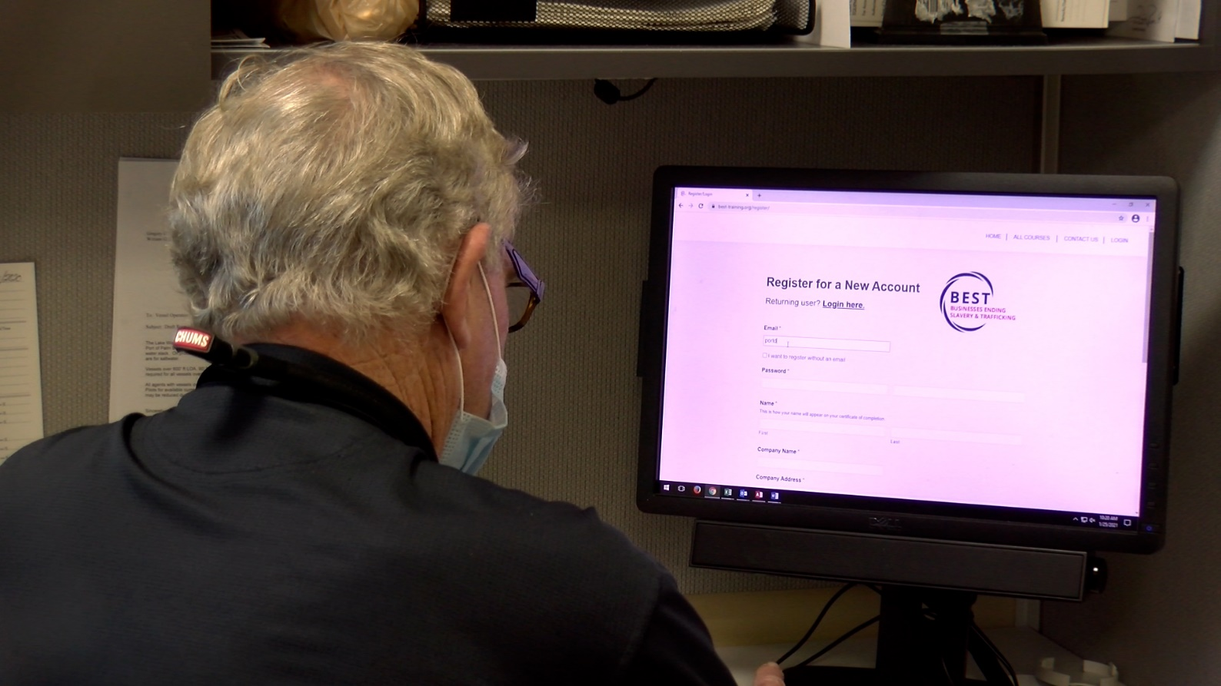
Key Objectives-
- Provide the virtual training to employees for an entire month starting in January

- Disseminated emails to employees congratulating those who completed the training to draw attention on employee participation
- Publish a joint news release with the organization, share post on social media and produce video to be shared on the Port’s website, YouTube channel and social media pages
- Provide local reporters with everything they needed to easily put together a video story without stepping foot on the Port. In addition, we found a way to make the story timely in the month of February, by weighing in on how human trafficking ties in with the Super Bowl

Audience-
- Primary- -Port of Palm Beach employees and tenants
- Second- members of the community and district, non-maritime partners and the media

- Actions and Outputs
STRATEGIES-
- Work closely with the BEST communication team to draft a joint news release, flyer for employees and reach as many media partners as possible
- Engage our Commissioners in the campaign process to increase the participation of employees
- Prepare certain Port staff members for in-house shot interviews and make the interviews relatable to the average individual
- Incorporate employees in video piece to boost their interest of the training
- Constant communication with local media to secure coverage of the port’s initiative and find a way to provide them with different interviews

ACTIONS-
- Spent two weeks working on joint news release with BEST. Included a quote from our Port Executive Director. The news release was distributed January 25 when the training became available to employees.
Read news release
- Disseminated flyer to employees promoting the training and providing instructions on how to access the training
- Created logins and passwords for security team to avoid technical issues
- Posted National Human Trafficking Hotline phone numbers in different languages in several locations and security gates at the Port
- Prepared interviewees with questions and answers prior to PIO filming
- Shot video of employees taking the training and working
- Provided all three broadcast stations with video content to produce their own stories. This required conducting several interviews so the stories could be slightly different
- Used the content given to the media to produce a Port owned story that was shared on our website, YouTube channel and social media pages
- Coordinated interview for BEST for a local newspaper article
- Featured campaign in February newsletter
- Posted about campaign on social media pages in at least on three different occasions
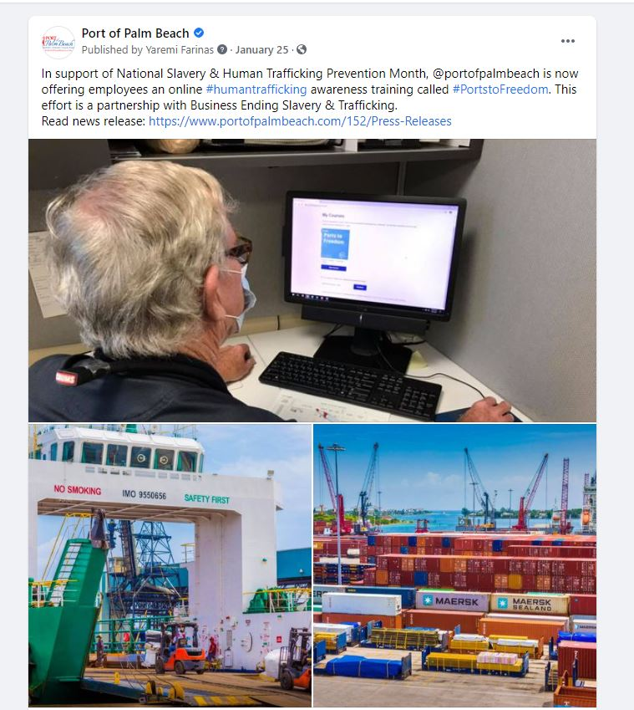

- Communication Outcomes
We received positive feedback from all parties involved. Our Commissioners were exceptionally proud of the exposure we received throughout the month. The employees were grateful to learn something new and were able to show their family and friends their efforts in action. Our port produced video was watched by more than 800 people with a majority of the viewership occurring on Facebook.
Watch Port video
The overall media coverage reached more than 275,000 people, according to the media monitoring platform we utilize, Meltwater.
News coverage:
Watch local ABC station’s news story
Watch local NBC station’s news story
Watch local CBS’ station news story
Read Maritime Logistics Professional news article
Read Security Magazine news article
Read Palm Beach Post news article
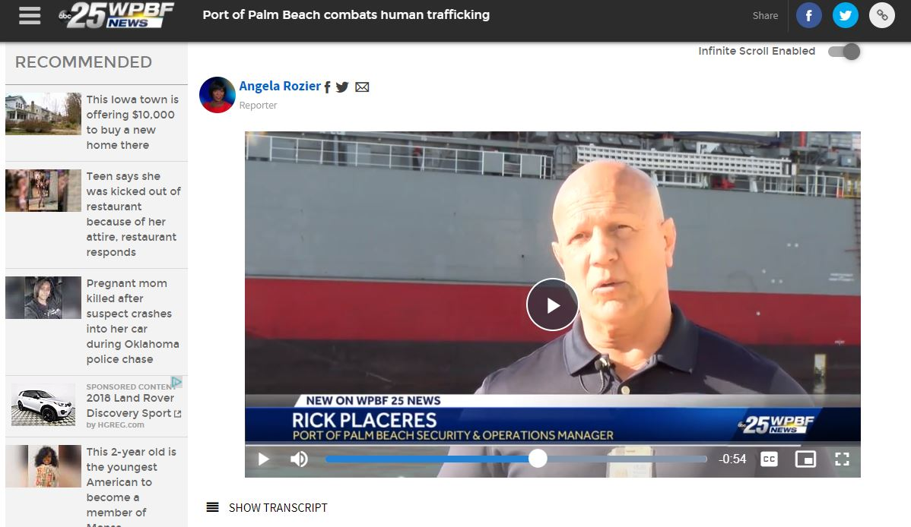

The “BEST” team provided us with the following feedback on our communication efforts through the campaign.
“In November 2020, BEST began a conversation with the Port of Palm Beach about training their employees on human trafficking; they promptly began offering our training to all their employees in January 2021. To raise awareness and influence their peers, Port of Palm Beach created a very effective and comprehensive internal and external communications strategy. This included issuing a joint press release, securing television interviews,
distributing flyers, and creating videos.

The Port of Palm Beach’s leadership and staff were creative, enthusiastic collaborators that put just as much effort into publicizing the importance of human trafficking prevention as they did their own accomplishments. We could not have asked for a better partner” -Dr. Mar Brettmann, CEO and Founder of Businesses Ending Slavery and Trafficking (BEST)

The campaign also encouraged our Port Executive Director to sign the U.S. Department of Transportation’s National Pledge Program against human trafficking.

