Tenant Spotlight: Three Generations at Heavy Lift Services
AAPA 2021 Communications Awards Program, Classification 4- Community/ Educational Outreach
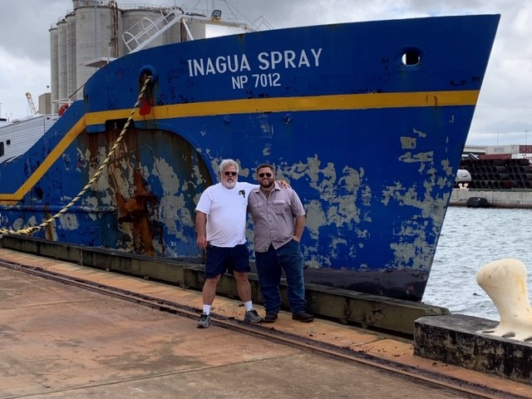
Summary:
The Port of Palm Beach started highlighting its tenants in an educational video series called “Tenant Spotlight” in mid-June 2019. The Port of Palm Beach’s “Tenant Spotlight” is designed to help the community understand the different businesses operating at the Port, the types of cargo the port handles and the economic impact our Port has on the local and state economies. The educational video was entirely produced in house by Public Information Officer Yaremi Farinas. She received videography assistance from the Director of Planning and Development, Carl Baker.
This particular “Tenant Spotlight” features a multigenerational stevedore company called Heavy Lift Services.

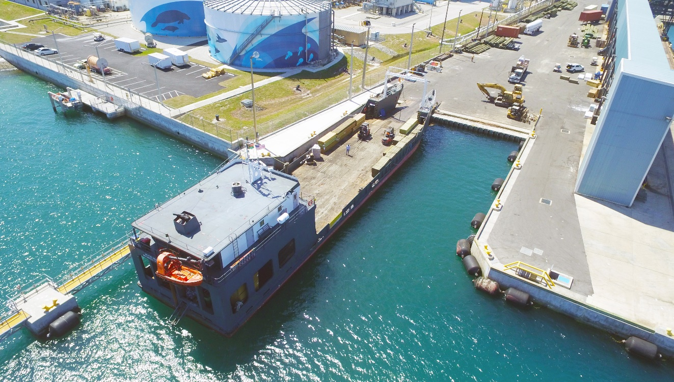
Heavy Lift Services was founded by Alan Dias in 1965 while working at the Port of Palm Beach for West India Shipping Line. After his passing, his son Glen Dias took over the business and now his son Joey is learning the ropes.
The company handles approximately 62,000 tons of cargo a year. Throughout the decades, they’ve handled special assignments including loading a satellite to Guyana, a gun ship that was transported to Israel and palm trees for a private island in the Bahamas. The video tells a story about the family business, its services, the type of cargo they handle, the skills it takes to be a stevedore and the future of the company.
Our “Tenant Spotlight” is posted on our YouTube channel, then uploaded on the Port’s website, published in our monthly e-newsletter and shared on all social media platforms including Facebook, Instagram, Twitter and LinkedIn. Watch video here.
Time: 0-5:00

COMMUNICATION CHALLENGES OR OPPORtunities
While port staff conducts presentations and tours to members of the public, our new “Tenant Spotlight” gives the public an inside look at our world, without physically being present on port property. For this particular video, we focused a stevedoring company that handles unusual cargo and is the oldest single-family owned business operating at the Port.
OPPORTUNITIES AND CHALLENGES:
With this video, we had the opportunity to show the community how port workers are dedicated to the industry and how a majority of them are here to stay. Their livelihood supports our local, state and international economies. The video puts a face to the title “stevedore.”
In addition, we had the opportunity to provide the viewers with numerous visual perspectives by shooting drone video of vessels arriving, a time lapse of the stevedores loading a RO-RO ship and old photos of the company’s original owner and the special projects they’ve accomplished in the past. Compiling the old photos was a tedious task because of the number of photo albums we had to sort through.
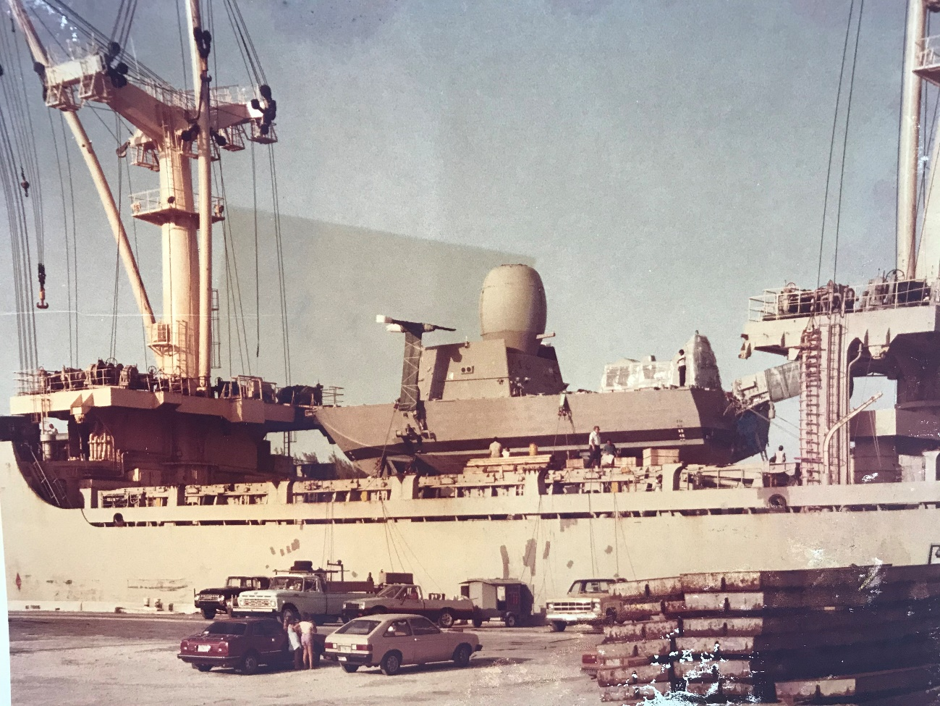

While working on this project, the obvious challenge was COVID-19. The country shutdown, the slowdown of operations and absences due to sickness, left us no choice but to delay the production of the video for at least six months. As we became more accustomed to living in a pandemic world, we began the filming process in September 2020. The turnaround time was two months.
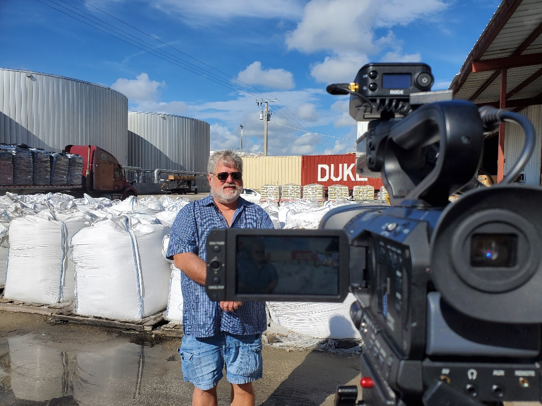
Another challenge we faced was securing an interview with a customer. We had to explain the benefit of the individual doing the interview and luckily we conducted the interview two weeks after the first shoot date.

- Complementing the Overall Mission

Port of Palm Beach’s mission is to sustain world-class port operations and serve as a catalyst for the regional economy and a pillar for the local community. This Tenant Spotlight shines a light on why Heavy Lift Services is a “world class” port operation. The projects the company has handled throughout the years, the rapport they have with their customers and the long-term commitment they

have with the Port, shows their value. The video details its partnership with local entities when providing relief to disaster victims in the Caribbean.
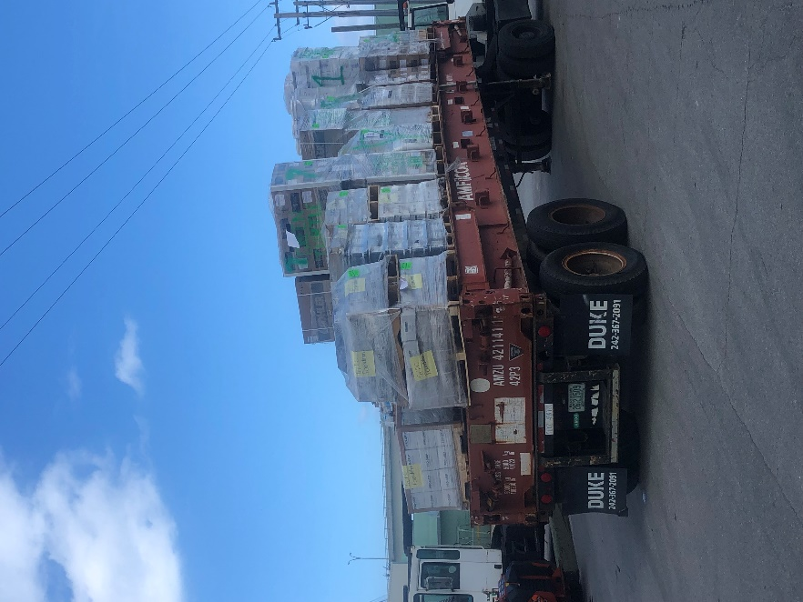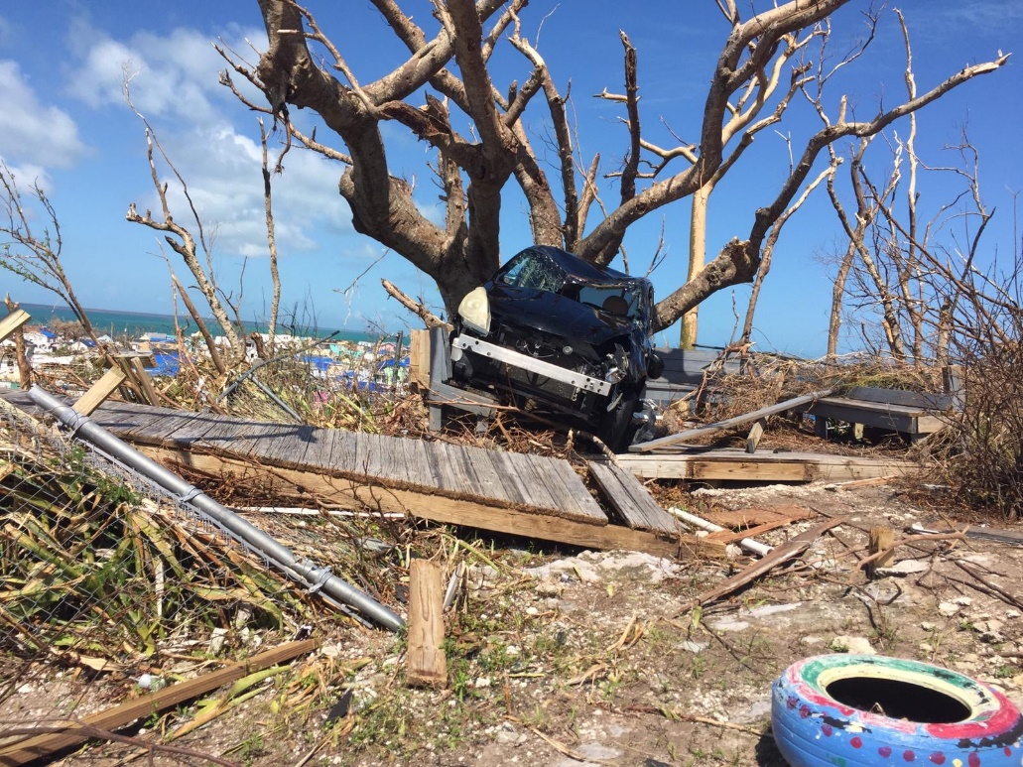

- Planning and Programming Components
Our goal was to produce an engaging video that illustrated how Port of Palm Beach has people who truly care about the Port and the community. We highlighted generational stevedores who live and breathe the port business.
Key Objectives:
- Show the evolution of a local family owned business and how a company can succeed at Port of Palm Beach
- Display the roles of a stevedore
- Create an educational video that is not time sensitive and can be used in the future
- Effective use of video
- Capture distinct footage
- Showcase special cargo projects
- Use natural sound to help tell the story
- Reach at least 1,500 people using our website and social media
- Receive positive feedback from our tenant

Audience:
- Primary- members of our neighboring communities
- Secondary--Port of Palm Beach tenants, commissioners, employees, stakeholders and local and Caribbean customers

- Actions and Outputs

This project took months of planning and developing strategies to achieve our goals.
Strategies:
- Constant communication with Heavy Lift Services to secure interviews
- Close contact with Port Duty Officer for vessel scheduling
- Requested video and photos that displayed a perspective we were unable to capture
- Provided a list of questions to prepare interviewees for the interview
- Brainstormed photos and footage needed to tell the story
- Transcribed all video before writing and editing

Timeline:
August 13 –Began communicating with company about possible shoot dates and interviews needed for the video
August 26- Rescheduled shoot date due to family emergency
September 4- Emailed the company list of interview questions
September 7—Visited the company’s office to sort through old photos
September 8- Captured drone video of a customer vessel being unloaded by Heavy Lift Services

September 11- Filmed three interviews with owner of company Glen Dias, his son Joey Dias and his wife Tina Dias. Also, shot video of stevedores loading and unloading vessels.

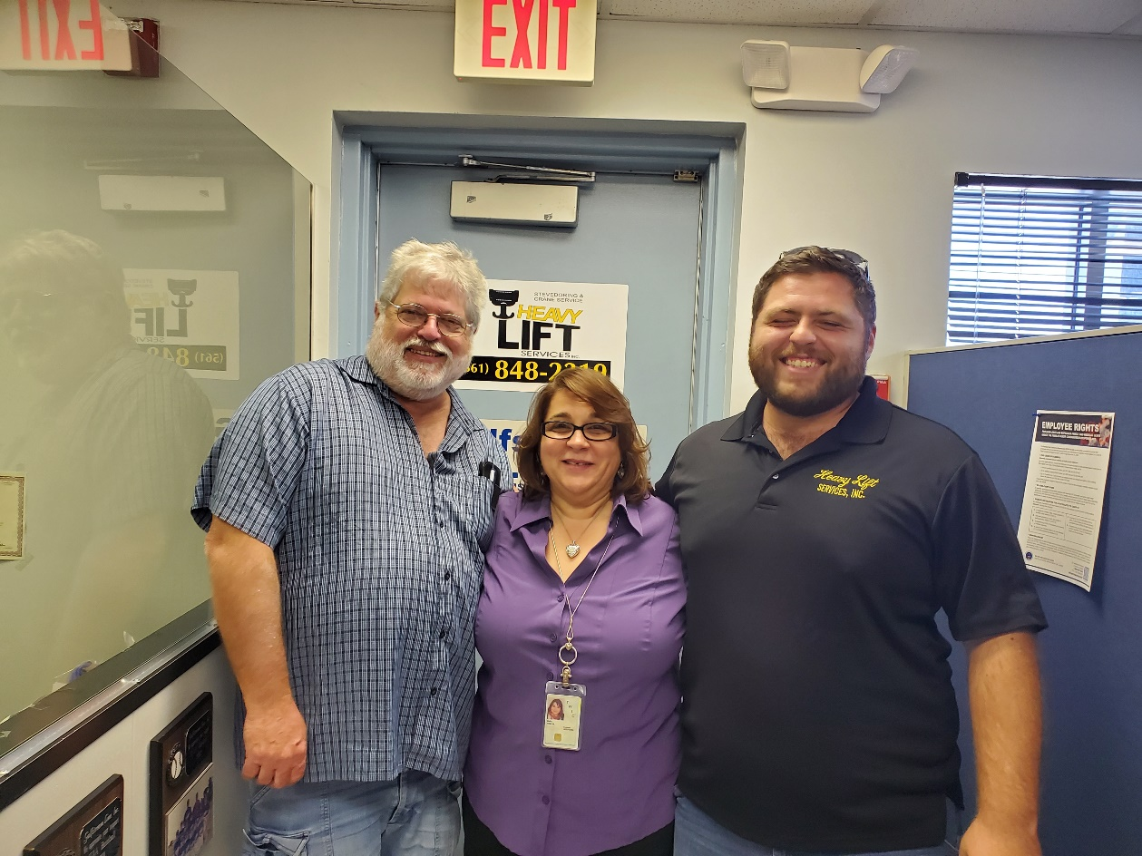
September 14- Used port owned drone to film charter vessel docking at the Port
September 16- Interviewed the company’s customer Patrick Koenig with the Green Turtle Cay Foundation
September 18- Received requested photos from Mr. Koenig
October 1- November 1- Transcribed all interviews, wrote script and edited video all in-house
November 14th- Shared video with Heavy Lift Services
November 16- Made suggested changes to video
November 17-Recieved approval from Executive Director
November 18—Video published on port website, YouTube and social media pages

- Communication Outcomes
We published our Heavy Lift Services “Tenant Spotlight” on our website, YouTube channel and social media pages on November 18, 2020. We received the most views on Facebook with more than 1,200 video views. We reached more than 3,400 people. The feedback was positive with 23 shares. The family also shared the video on their personal Facebook pages where they received positive feedback on the video with more than 25 comments, including the three below.
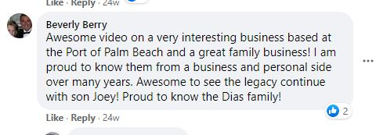
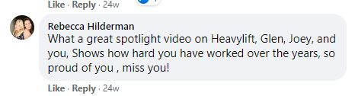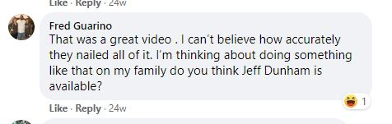

Heavy Lift Services was extremely grateful the Port dedicated the time to showcase the company’s work.
“I got a ton of great feedback from a lot of people, customers, friends and even family. They were so interested in learning about the origins of the company, that we are three generations and literally seeing the third generation grow up and becoming a vital part of the business. Seeing firsthand the ships we load, what we do and how it impacts other people was well received, I had a lot of people say they had no idea of all the things we actually did – they loved it.”
- Tina Dias

“I thought our video was great, but I might be a bit partial. I think the concept of the Tenant Spotlight is a great idea. I think most people do not really have any idea what kind of companies are within a Port and what they really do. This gives people a clear view of many different kinds of companies that are in there community that they were most likely unaware of and how they impact their community and beyond.”
- Glen Dias

“I love what I do for a living. Any chance to show what it is and the history involved on my side is well worth my time. When most people ask what I do for a living and I say I am a stevedore, I get a funny look and a “what’s that”. Most people have no idea what goes on at a port, even friends I have explained how something works, they didn’t quite get it until they saw the video.”
-Joey Dias

We believe our “Tenant Spotlight” project continues to educate our community and has created a strong rapport between our tenants and Public Information Officer.

