AAPA 2021 COMMUNICATIONS AWARDS

Greater Lafourche Port Commission (PORT FOURCHON)

Entry Classification: 8. Periodicals (Newsletters & Magazines)

The Port Messenger has been published since 2020 to promote the Greater Lafourche Port Commission and Port Fourchon. The original title of this four-page newsletter was State of the Port. Beginning in 2021, this quarterly newsletter was expanded to include eight pages and took on the new moniker of The Port Messenger. It is used to communicate with our tenants and users, state and federal partners, and other individuals that visit the Port for tours. Each newsletter features stories highlighting the latest happenings in Port Fourchon and is distributed both electronically and through the mail.

- What are/were the entry’s specific communications challenges or opportunities?

Whenever you choose to produce a document related to your agency it requires time and energy to produce. Since all the content is produced in-house by the Communications Director, this did present a challenge, but when judged against the opportunity to share valuable information with those following our agency, the decision to move forward with its production was easy.

Describe in specific and measurable terms the situation leading up to creation of this entry.
Having no official GLPC/Port Fourchon produced newsletter, it seemed only natural that we should develop a quarterly document for distribution.

Briefly analyze the major internal and external factors that need to be addressed.
Although we have a well-sourced website that features loads of good information, we needed a stand-alone document (i.e. newsletter) to address the latest happenings at the GLPC/Port Fourchon.

- How does the communication used in this entry map back to the organization’s overall mission?

By extracting the definition of our organization’s mission, it is easy to see how the use of colorful feature stories can enhance and shine a light on the mission of the GLPC/Port Fourchon.

Our Mission: The Greater Lafourche Port Commission, a political subdivision of the state of Louisiana, facilitates the economic growth of the communities in which it operates by maximizing the flow of trade and commerce. We do this to grow our economy and preserve our environment and heritage. The Port Commission exercises jurisdiction over the Tenth Ward of Lafourche Parish, south of the Intracoastal Waterway, including Port Fourchon and the South Lafourche Leonard Miller, Jr. Airport.

- What were the communications planning and programming components used for this entry?

The planning effort was to designate a patterned approach to highlight items that would better explain what the GLPC/Port Fourchon had going on in a quarterly format. The items were developed through ideas gathered from looking at other periodicals.

Describe the entry’s goals or desired results.
The goals of the newsletter are to provide a useful document for visitors of the Port as well as to increase awareness using physical, social media, and email distribution platforms.

Describe the entry’s objectives and list specific, measurable milestones needed to reach its goals.
There are no specific objectives other than increasing exposure using a document that highlights the many amazing things that routinely happen at the GLPC/Port Fourchon.

Identify the entry’s primary and secondary audiences in order of importance.
The primary audience is legislative leaders and the community at large, but just as important (although secondary) is our tenant and users of Port Fourchon.

- What actions were taken and what communication outputs were employed in this entry?

Contracting a media company to produce and layout the newsletter was the first step along with developing an approach to make use of various communication platforms to distribute the said newsletter.

Explain what strategies were developed to achieve success and why these strategies were chosen.
By blanketing our communication platforms with the said newsletter, we have achieved our main exposure objective.

Specify the tactics used.
Email, social media, and mailing physical copies of the newsletter.

Detail the entry’s implementation plan by including timeline, staffing, and outsourcing used.
The implementation started with the creative execution of determining the content for a newly launched newsletter. The first year (2020) was chosen to coincide with the GLPC/Port Fourchon celebrating its 60-year anniversary. Three newsletters were produced, which led to the tweaking of the newsletter to expand from a four-page to eight-page format in advance of the unveiling of a new branding logo at the start of 2021. Outside of the employment of a local media company to work with us on the layout of the document, all other efforts were undertaken internally.

- What were the communications outcomes from this entry and what evaluation methods were used to assess them?

The main outcome is having individuals understand we have a newsletter that features a wealth of information. Items from these newsletters have been used by others to help describe what’s going on at the GLPC/Port Fourchon as well as give the GLPC/Port Fourchon an entry way to pursue other opportunities in the realm of communications.

Describe any formal/informal surveys used, or anecdotal audience feedback received, that helped in evaluating the success of this entry.
We have received favorable reviews in the way of informal comments via our social media platforms and at virtual and in-person gatherings where we attend on behalf of the GLPC/Port Fourchon. We have even had tenants request physical copies of the newsletter to put in their lobby for distribution to visitors.

If possible, explain how this entry influenced target audience opinions, behaviors, attitudes, or actions.
This entry has aided in shining a further light on the importance of the GLPC/Port Fourchon thanks to compelling feature stories that highlight the many projects and efforts the GLPC/Port Fourchon are constantly involved in for the betterment of not only the surrounding community, but the state, and nation.
Links to our newsletters:

Volume 1
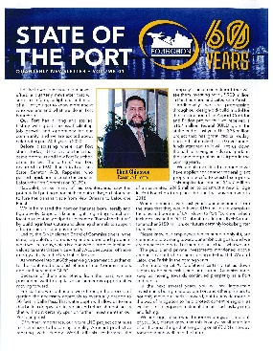

http://portfourchon.com/wp-content/uploads/2020-Q1-State-of-the-Port-GLPC-Newsletter.pdf

Volume 2
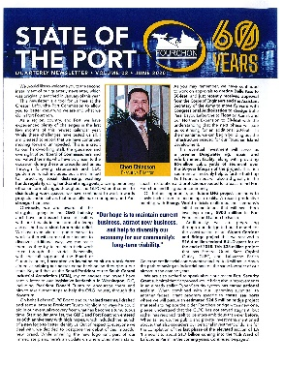

http://portfourchon.com/wp-content/uploads/2020-V2-State-of-the-Port-GLPC-Newsletter.pdf

Volume 4
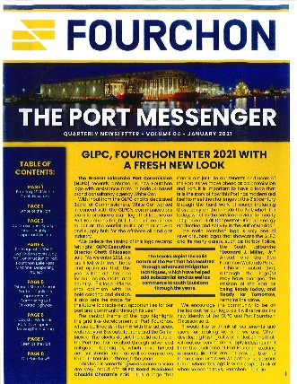

https://portfourchon.com/wp-content/uploads/2021-V4-State-of-the-Port-GLPC-Newsletter.pdf

