AAPA 2021 COMMUNICATIONS AWARDS

Greater Lafourche Port Commission (PORT FOURCHON)

Entry Classification: 13. Visuals-Only Presentations

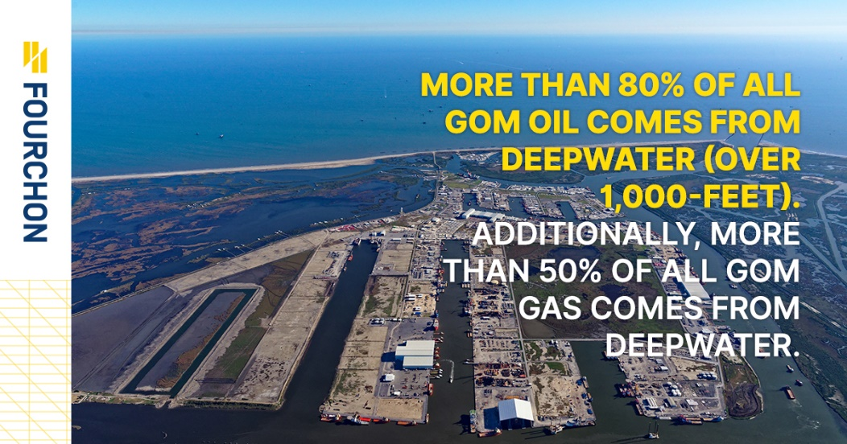

The GLPC/Port Fourchon launched a new main logo with various subsets in early January 2021. Among other activities to get increased eyes on this logo, a series of infographics were posted daily across numerous social media platforms. These infographics helped tell the story of the GLPC/Port Fourchon in a more crisp, concise way.

- What are/were the entry’s specific communications challenges or opportunities?

This particular endeavor was one that was looked at as an excellent opportunity only. By harnessing the strength of good visuals and creating individual graphics that could tell our story effectively and concisely, we felt this produced an excellent opportunity to further tell our story to others.

Describe in specific and measurable terms the situation leading up to creation of this entry.
As we embarked on 2021, the GLPC/Port Fourchon launched a new branding portfolio that included a sleek, modern logo. In the process of rolling out this logo and its subsets, we devised ways to showcase our new logo in a number of creative ways such as infographics.

Briefly analyze the major internal and external factors that need to be addressed.
When determining what will work and what won’t in the realm of communications you are often left to go through a period of trial and error. Internally, we knew we needed some catchy items to engage with our followers, thus we thought infographics would be a direct way to have our social media audience learn more about us.

By showcasing the diversity of the GLPC/Port Fourchon through the strategic deployment of several well-vetted graphics that speak on the areas of interest that involve the GLPC/Port Fourchon specifically.
- How does the communication used in this entry map back to the organization’s overall mission ?

Explain the organization’s overall mission and how it influenced creation of this entry.
Our Mission: The Greater Lafourche Port Commission, a political subdivision of the state of Louisiana, facilitates the economic growth of the communities in which it operates by maximizing the flow of trade and commerce. We do this to grow our economy and preserve our environment and heritage. The Port Commission exercises jurisdiction over the Tenth Ward of Lafourche Parish, south of the Intracoastal Waterway, including Port Fourchon and the South Lafourche Leonard Miller, Jr. Airport.
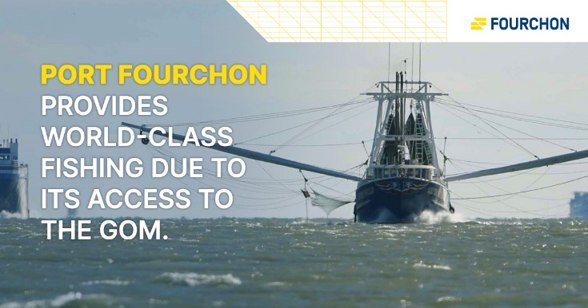
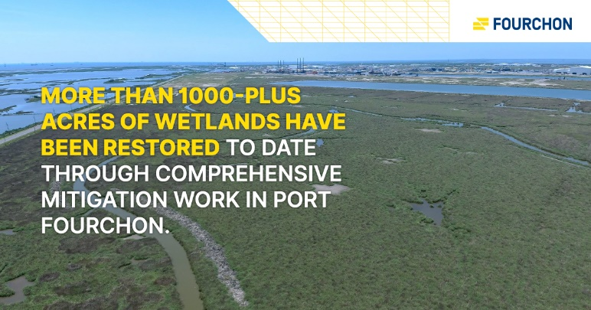

- What were the communications planning and programming components used for this entry?
When hashing out ideas during our logo rollout we determined it might be a good idea to make use of infographics to showcase our new logo to our social media audiences.

Describe the entry’s goals or desired results.
Attention.

Describe the entry’s objectives and list specific, measurable milestones needed to reach its goals.
Outside of drawing attention to our new logo, the main measurement method used were the amount of reactions and shares of the infographics we released daily on our social media pages. This deployment of an infographic daily proved popular with our social media audience as we received good viewership, shares, and reactions from our followers.

Identify the entry’s primary and secondary audiences in order of importance.
The primary audience were current followers of our social media pages, specifically Facebook. Secondary to this was our followers on LinkedIn and Twitter.

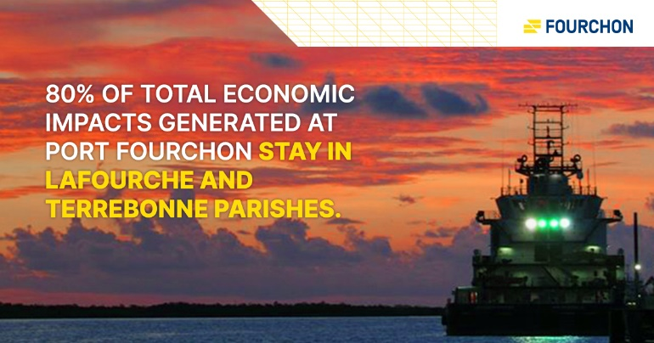

- What actions were taken and what communication outputs were employed in this entry?
We worked with the same media consultant agency that crafted our new branding sets and logo to assist us in developing these infographics. We provided the verbiage and images, while they worked on the layout and sizing of the images so they could be compatible across all our social media pages.

Explain what strategies were developed to achieve success and why these strategies were chosen.
The strategy was to capitalize on the success of our ability to build-up the Gulf South’s largest Port-related Facebook audience through the use of content-rich infographics that could tell our story effectively in a more colorful, easy-to-read way.

Specify the tactics used. (To carry out strategies)
We created a month’s worth of graphics to coincide with the first month of our logo launch. These infographics (one per day) were posted strategically during the work week in the 4 to 5 p.m. timeframe.

Detail the entry’s implementation plan by including timeline, staffing, and outsourcing used.
We worked with our local media consultancy agency to create the infographics. A member of our media team posted these infographics right before leaving to go home daily.
- What were the communications outcomes from this entry and what evaluation methods were used to assess them?

The outcome was increased brand exposure. This was measured through metrics collected by our Information & Communications Clerk.

Describe any formal/informal surveys used, or anecdotal audience feedback received, that helped in evaluating the success of this entry.
The feedback was favorable in the since that it generated tangible social media traffic across our various platforms in the form of views, likes, shares, etc.

If possible, explain how this entry influenced target audience opinions, behaviors, attitudes, or actions.
It isn’t possible to determine this, but we can deduce from what we saw that these infographics never solicited a negative response. All the feedback we could see was on a positive tilt.

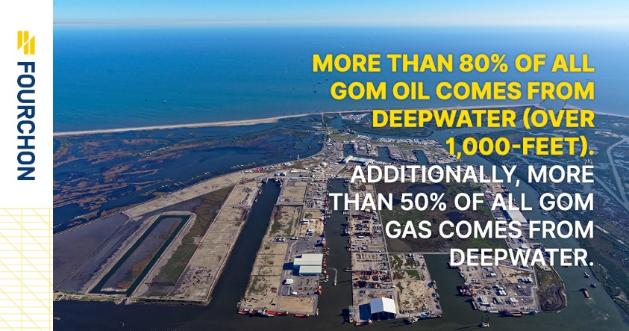
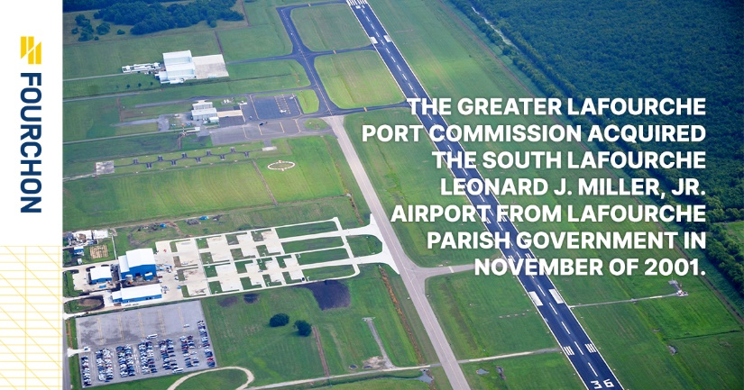
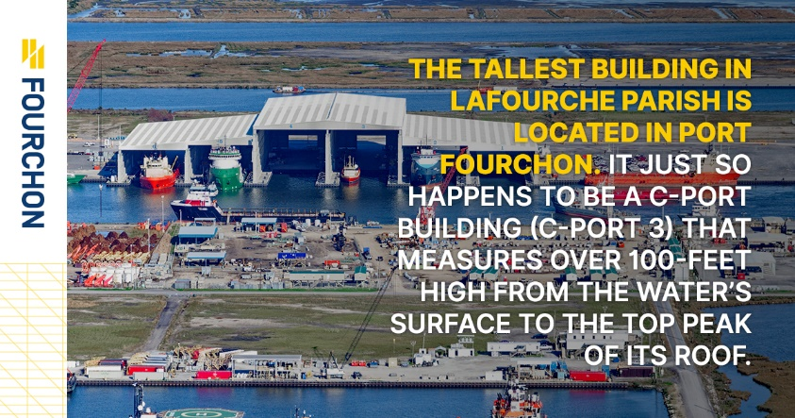
INFOGRAPHICS
