SUMMARY OF THE PROJECT OR PROGRAM

Green Marine is an environmental certification program for the North American marine industry. It is a voluntary, transparent and inclusive initiative that addresses key environmental issues through its 14 performance indicators. Participants are ship-owners, ports, terminals, Seaway corporations and shipyards. To receive certification, participants must benchmark their annual environmental performance through the program’s self-evaluation guides, have their results verified by an accredited external verifier and agree to publication of their individual results.

Guiding Principles
- Green Marine Environmental Program
- Annual Self-evaluation
- Green Marine Environmental Program
- For each applicable environmental issue, the participant must evaluate its environmental performance on a scale from 1 to 5 by using the self-evaluation guides provided by Green Marine.
- The company must submit the annual self-evaluation report, signed by the company’s CEO or most senior executive, to the Green Marine Secretariat by April 1st of each year.

GOALS AND OBJECTIVES
To receive certification, participants must benchmark their annual environmental performance through the program’s self-evaluation guides, have their results verified by an accredited external verifier and agree to publication of their individual results. Green Marine environmental certification program offers a detailed framework for maritime companies to first establish and then reduce their environmental footprint. Areas of interest include:

- Aquatic Invasive Species - objective is to reduce the risk of introducing and propagating aquatic invasive organisms and pathogens associated with ballast water discharges and biofouling. Launching a registry of invasive species found on port territory, to be conducted in collaboration with the government organization carrying out sampling activities.
- Dry Bulk Handling and Storage is to reduce cargo losses and dust generated during handling, transportation and storage of dry bulk. When we begin to look at Community Impacts the objective is to reduce the amount of noise, dust, odor and light to which people residing close to port facilities are exposed.
- Greenhouse Gases and Air Pollutants - work to reduce greenhouse gas and air pollutant emissions.
- Spill Prevention and Storm water Management - objective is to prevent spills and leaks of pollutants and manage storm water to minimize contamination into the environment (water and land).
- Dry Bulk Handling and Storage
- Community Impacts
- Environmental Leadership - looks to leverage the significant influence of port authorities and Seaway corporations as land owners and/or managers over the environmental practices of their tenants and/or users.
- Waste Management - increase waste diversion and reduce at source the waste arising from administrative activities and site operations.
- Underwater Noise - manage underwater noise sources during ongoing activities, development/construction, and/or port maintenance activities to reduce impacts to marine mammals.

Green Marine requires participants to adopt practices and technologies that will have a direct impact on the ground. The progress that participants make in this respect is evaluated with the help of performance indicators, which are revised yearly, in the spirit of continuous improvement at the heart of the environmental program. Additionally, the participants must:
- Adhere to Green Marine’s guiding principles regarding the need to continuously improve their environmental performance.
- Pay the annual membership fee assessed to Green Marine participants.
- Submit an annual self-evaluation report to the Green Marine secretariat.
- Agree to the external verification conditions established by the Green Marine Management Corporation.
- Agree to the publication of their self-evaluation results in Green Marine’s Annual Report and website.
- Achieve, during the first year of participation, level 2 for at least one performance indicator AND, as of the second year of participation, demonstrate an annual improvement of one level in at least one performance indicator until level 2 is achieved for all applicable performance indicators. The Port met level 2 in 8 categories addressed in 2020.

Additionally,
- The company must commit to complying with all applicable environmental laws and regulations and to diligently address any instances of non-compliance.
- If any major non-compliances where significant environmental impact has or may occur and where requested by Green Marine, the company will provide to Green Marine details of how the company plans to resolve the situation. Such measures provide Green Marine with assurance that the non-compliance is being addressed; however, through these actions, Green Marine does not assume any accountability or responsibility for overseeing the implementation of the action plan and/or assessing its adequacy.
- In instances of gross negligence or failure to address one or more issues of non-compliance, Green Marine’s Board of Directors will have the option to terminate the participant’s membership in the program.
DISCUSSION

Background
Port of Galveston began the Green Marine program in 2019. Throughout 2020, the Port of Galveston worked to meet the initial criteria, much of which involved capturing what we had done to date, monitoring regulations, establishing procedures, partnerships with local environmental agencies, awareness and training for our employees. But also, some investments. For instance purchasing recycle receptacles for al terminals and offices, recycling all paper, moving from plastic to personal water cups and beginning to look at construction materials that could be used that were more ecofriendly.

To become certified, the Port submitted its results to third party verification Green Marine accredited verifier. The first verification is required within the first two years of joining the program. The verification process includes on-site visits (with COVID-19 desk inspections were conducted and thorough documentation needed to audit results.

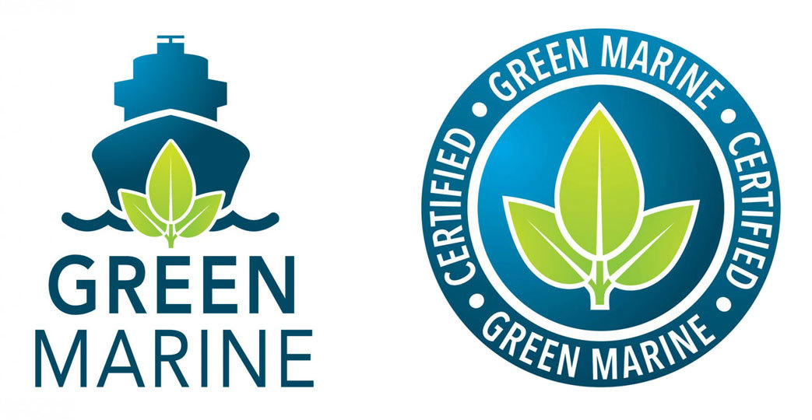
The Port of Galveston completed their self-evaluation and verification for the 2020 reporting year and was officially Green Marine certified at their Green Tech conference on June 3-5, 2021. The Port of Galveston received level 2 in seven of the 8 criteria measured and level I in one – aquatic species was voluntary for 2020 and not considered as part of the certification process.

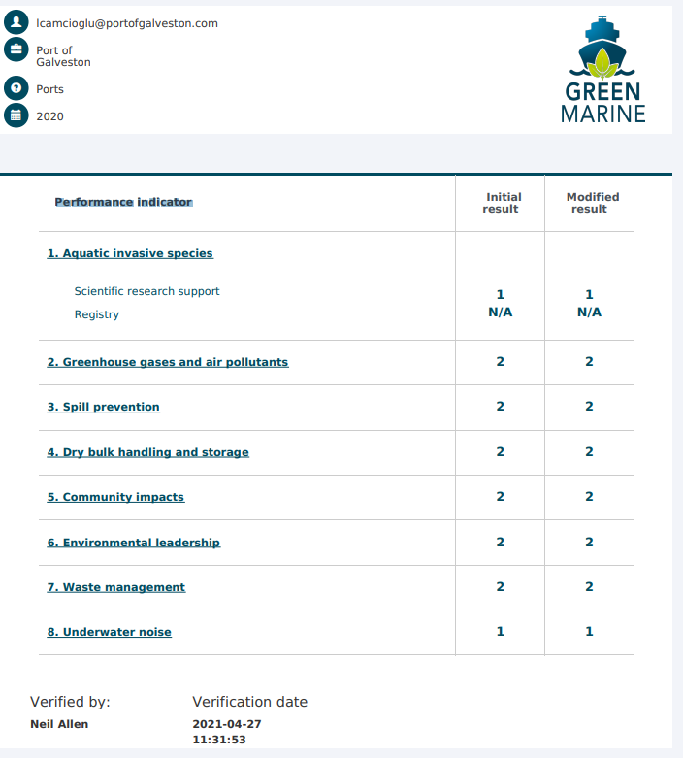

AWARD CRITERIA

In terms of the benefits to environmental quality, beautification or community involvement one of the first criteria the Port took up was waste management, one of eight areas of performance for ports in the Green Marine program. The Waste Management objective is to reduce waste in our administrative facilities and site operations. To be Green Marine-certified, the port must implement the majority of about a dozen actions that include the following:
- Install recycling bins in offices and facilities, including for used batteries, cartridges and fluorescent light bulbs
- Install waste disposal signage on port property
- Educate staff on waste management procedures, including reduce, reuse, recycle, and proper handling and disposing of hazardous waste
- Encourage the use of reusable, recyclable and compostable supplies
- Encourage tenants, users and contractors to minimize waste and to recycle
- Adopt an environmentally preferable purchasing policy that encourages sustainable purchasing practices

The Port voluntary engaged in this program voluntary in an effort to improve our impact on the environment. It is the first step of a long journey. In addition to respecting laws and applicable regulations, every Port that joins green marine agrees to:
- Demonstrate corporate leadership in the search for best environmental practices in accordance with a sustainable development approach.
- Carry out its activities in a responsible manner with a view to minimizing its environmental impacts.
- Aim for continuous improvement of its environmental performance.
- Develop and promote voluntary protection measures.
- Integrate sustainable development practices that are technically and economically achievable.
- Collaborate with governments and citizen groups in the progressive implementation of the action plans arising from the Green Marine Environmental Program.
Certification is just the beginning. Participating in Green Marine helps us identify and implement best practices, manage our environmental programs, measure our progress and strive for continuous improvement. Sharing new technologies and best practices with other Green Marine members is another benefit that we’ll tap into.

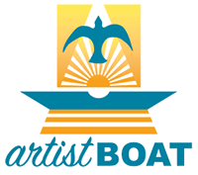
Green Marine also encourages collaboration with governments, port tenants and citizen groups in implementing action plans and green initiatives. In terms of creativity one of our approached is employee awareness and training is getting them out in the field to participate in green efforts. We’re collaborating with business and community partners, including the Artist Boat and Galveston Bay Foundation.
The Artist Boat Coastal Heritage Preserve currently encompasses a 690-acre conservation area on West Galveston Island. Artist Boat’s goal is to preserve and restore 1,400 contiguous acres from bay-to-beach. The Preserve is adjacent to West Bay, part of the Galveston Bay system – an estuary of national significance. The conservation area is one of the largest unfragmented, single-owner, undeveloped properties of its kind on Galveston Island. The Preserve is located approximately midway along the 32-mile barrier island. Port employees come out and help restore the native coastal prairie ecosystem. Workday tasks included planting native grasses, treating and removing invasive species.
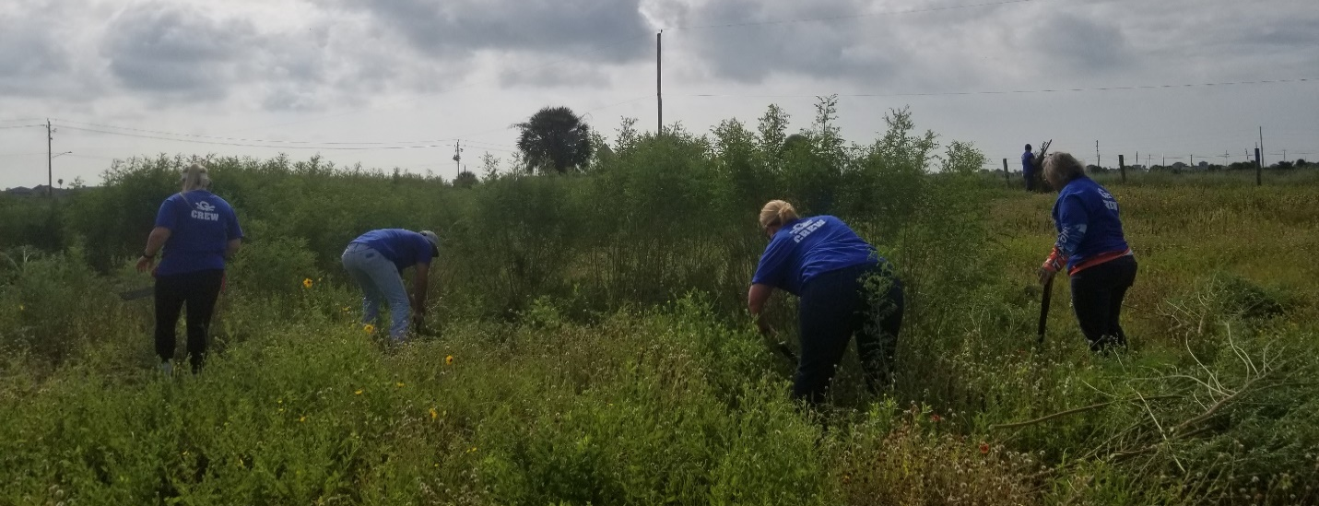
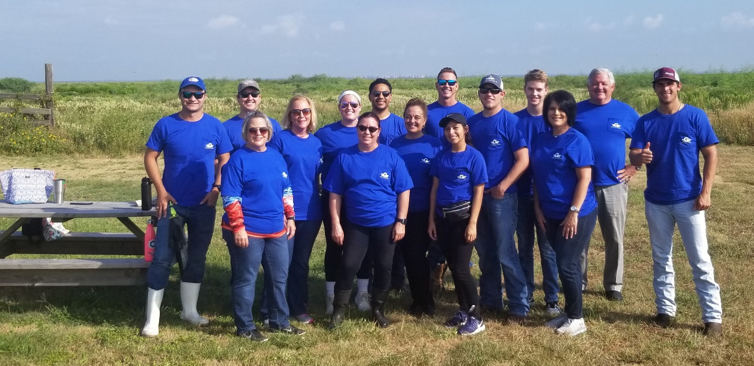
Most recently, port employee volunteers partnered with Galveston Bay Foundation and picked up trash and marine debris on a port-owned tract on Pelican Island. Galveston Bay Foundation is a conservation nonprofit that has served as guardian of Galveston Bay since 1987. Their mission is to preserve and enhance Galveston Bay as a healthy and productive place for generations to come. We work to facilitate a true cross-section of Bay interests through creative, inclusive and forward-thinking solutions to the challenges confronting Galveston Bay. Through actions and partnerships and a commitment to sound science and research, they have five main program areas in which we work on behalf of the Bay. They are education, advocacy, restoration, conservation and protection. Each program area is broad and deep, offering a range of solutions and opportunities to preserve the Bay for generations to come.
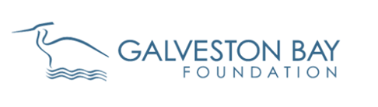

Port employees helped to pick-up debris washed on the shore. We have now partnered with Galveston Bay to allow regular sampling which has led to NOAA invited Galveston Bay to submit a full application for the shoreline cleanup grant. In this effort, in total, the volunteers and staff come out monthly and inventory debris and clean up. Below is a high level summary of the types of debris that they identified 4th quarter 2020.

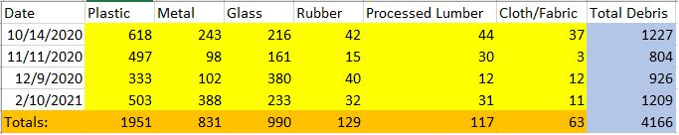

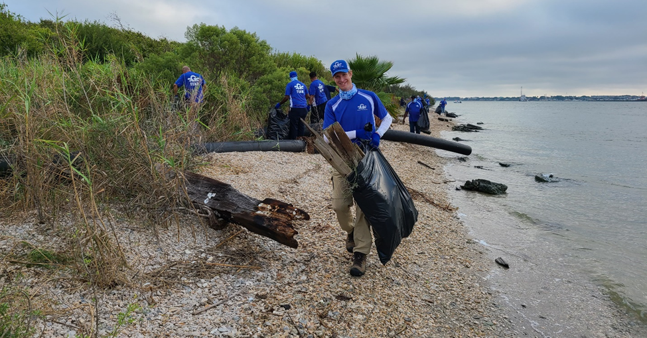

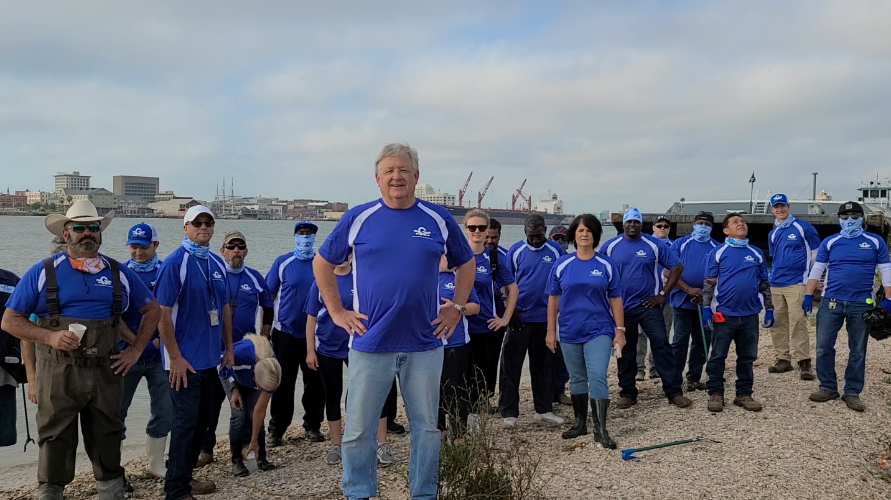

Participating in the Green Marine Program is incremental and looks for continuous improvement. During COVID-19, with no cruise revenue, we were not out to spend money getting all the bells and whistles in terms of ecofriendly equipment, operations and products. We were more concerned with running the port in a way that is aligned with our values, operates efficiently, and can differentiate from its competitor’s just makes good business sense. In terms of cost effectiveness, the Green Marine Program has brought the Port the following benefits:
- Provides practical steps an extension of our values and helps to make sure that we do what we can do to operate sustainably.
- Provides a framework that ensures that the Port is looking at several key areas.
- Implementing green practices were we can save money. For example, energy efficient lighting can reduce your energy bill and recycling can help reduce your garbage bill.
- Differentiate from competitors. More consumers are looking to support companies that demonstrate a commitment to sustainability.
Green Marine’s members are committed to strengthening the North American marine sector’s environmental performance through a process of continuous improvement, stronger relations with stakeholders, and increased overall awareness of the marine industry’s activities and environmental benefits.

Green Marine uniqueness lies on its advisory committees’ composition: it brings industry stakeholders, legislators and environmental groups representatives to the same table. Together, they provide input and advice on different aspects of the program’s development. They are the ones giving shape to the criteria for each performance indicator making sure it is tailor-made for ports thereby making success very transferrable to other ports.

Regional input is a core aspect of the Green Marine program. The committees are structured to ensure that perspectives and priorities from different geographic regions are reflected in the development of program. All Green Marine participants are invited to join in the work of the advisory committee where success with green initiatives, technology, innovation, challenges, and innovation can be shared.

