**AAPA 2021 COMMUNICATIONS AWARDS**

**Greater Lafourche Port Commission (PORT FOURCHON)**

**Entry Classification: 10. Social Media/Web-Based Media**

The Greater Lafourche Port Commission (GLPC) - Port Fourchon established its social media presence in 2016 with the launch of its official Facebook page. Since then, we have branched out and added a Twitter, Instagram, YouTube, and LinkedIn page as well. All these pages have performed well with Facebook, LinkedIn, and YouTube leading the way.



*1. What are/were the entry’s specific communications challenges or opportunities?*

When moderating and developing content for social media pages the challenge is always to strike the right balance and use these platforms as a method to relay important information, while also having some fun as well.

*Describe in specific and measurable terms the situation leading up to creation of this entry.*

We have had a presence on these various platforms for several years but have undergone a lot of changes and growth in the last two years, ending on May 1st of this current year.

*Briefly analyze the major internal and external factors that need to be addressed.*

We operate these pages with a single moderator but make use of an additional employee of the GLPC/Port Fourchon to help post daily content to our pages. When posting information, we are always looking for content that is helpful, but at the same time interesting and light-hearted/fun on occasion. By striking the right balance as previously stated, we feel like that’s the reason why we maintain such a solid social media following.

*2. How does the communication used in this entry map back to the organization’s overall mission?*

We touch on all the issues stated in our overall mission when generating content for our social media pages.

*Explain the organization’s overall mission and how it influenced creation of this entry.*

Our Mission: The Greater Lafourche Port Commission, a political subdivision of the state of Louisiana, facilitates the economic growth of the communities in which it operates by maximizing the flow of trade and commerce. We do this to grow our economy and preserve our environment and heritage. The Port Commission exercises jurisdiction over the Tenth Ward of Lafourche Parish, south of the Intracoastal Waterway, including Port Fourchon and South Lafourche Leonard Miller, Jr. Airport.

*3. What were the communications planning and programming components used for this entry?*

We have screen captures of our different pages we planned on featuring, which are our Facebook, LinkedIn, and YouTube pages. To showcase our growth, we used a simplistic bar graph that highlights the amount of gains we’ve made in terms of followers and subscribers of these pages.

*Describe the entry’s goals or desired results.*

Since taking over the function of moderator in late 2018, the goal was to increase the number of followers across our platforms starting with a concerted effort to do so on Facebook.

*Describe the entry’s objectives and list specific, measurable milestones needed to reach its goals.*

After starting with a following of under 6,000 individuals in late 2018, the hope was to grow our following enough to where we’d lead the entire Gulf Coast in terms of Facebook followers for Port-related pages. By early 2020, this goal was achieved, as we now have well over 12,000 followers. In 2020, a further milestone that was pursued was to grow all our social media pages by at least 20 percent. This goal was met as well.

*Identify the entry’s primary and secondary audiences in order of importance.*

The primary audience is our local/regional population, but secondary to that is an audience that reaches around the entire state and country.

By flooding our pages with rich, vibrant content we have assured ourselves of having people take an active interest in our various social media accounts.

*4. What actions were taken and what communication outputs were employed in this entry?*

*Explain what strategies were developed to achieve success and why these strategies were chosen.*

We use specific hashtags to draw attention to our posts and make sure we invite people who don’t currently follow us. It must be noted that on Facebook, we have NEVER used the boost function to boost any our numbers. We have truly taken an organic, in-house approach to growing our Facebook audience.

*Specify the tactics used.*

Activity and good information mixed with solid pictures and graphics seem to have a way of piquing the curiosity of followers and other not familiar with who we are or what we do. This has been a key strategy employed to grow our presence on our social media pages.

*Detail the entry’s implementation plan by including timeline, staffing, and outsourcing used.*

In late 2018, we had an established presence on Facebook/Twitter/Instagram, but it wasn’t until early 2020 that we added our YouTube platform to the mix. We had a static LinkedIn page until 2020 when the pages were reconfigured, re-imaged and brought back online in a useful, beneficial way. By using a staggered approach to bringing additional social media accounts and content online, we feel as if we found success since we were calculated about giving our followers new platforms to follow us on.

*5. What were the communications outcomes from this entry and what evaluation methods were used to assess them?*

The outcomes are best described by looking at the bar graphs that show how with proper planning and execution of posts it is possible to grow your social media pages at an impressive clip.

*Describe any formal/informal surveys used, or anecdotal audience feedback received, that helped in evaluating the success of this entry.*

The evaluation metrics we used are how we’ve maintained followers and grown our audiences over the last two years. We have received many positive comments and correspondence that indicate to us we are doing a good job with presenting valued information to our community and other followers who are not from this area.

*If possible, explain how this entry influenced target audience opinions, behaviors, attitudes, or actions.*

By echoing certain facts repeatedly through our various pages, we hope we have embedded certain tidbits about our Port in the minds of our followers that they can in turn spread to others.

<https://www.facebook.com/PortFourchon/>

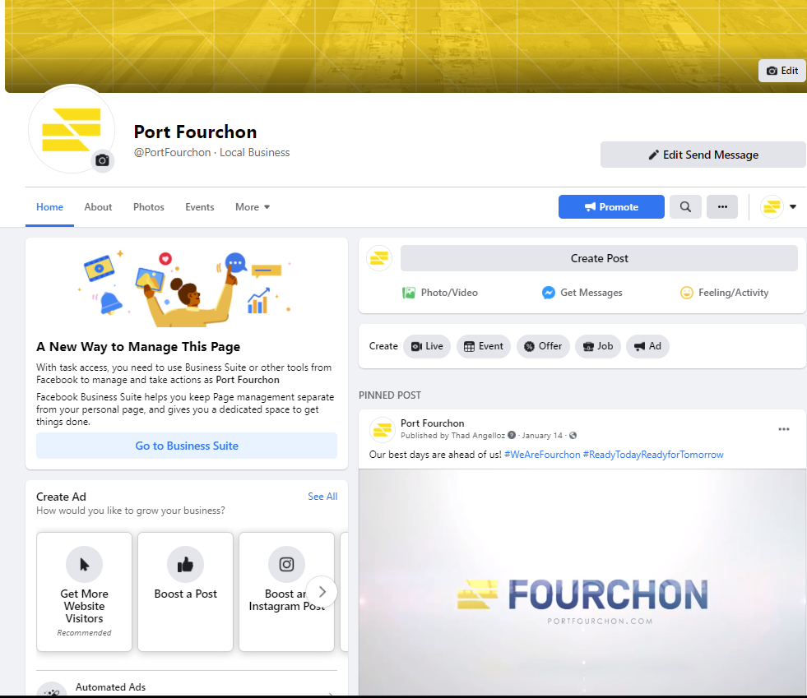



**Increase from 2019**

**29.92%**

<https://www.youtube.com/channel/UCFM6mpgt3OSU0a92lu9l99A>

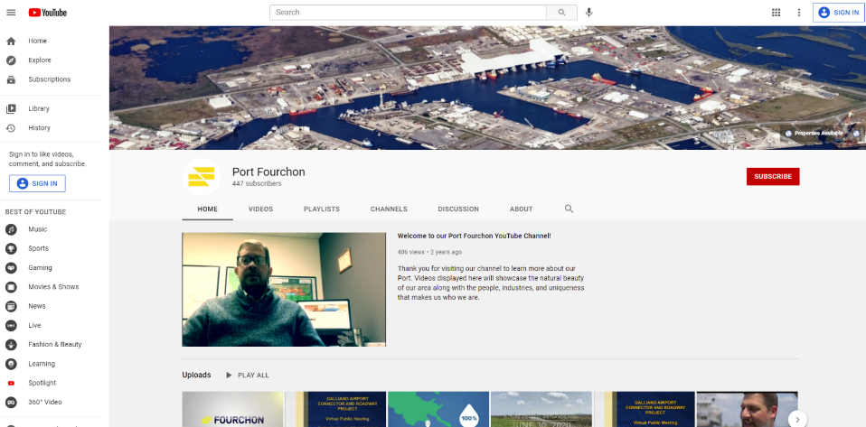





**Increase from 2019**

**250.86%**

<https://www.linkedin.com/company/greater-lafourche-port-commission>

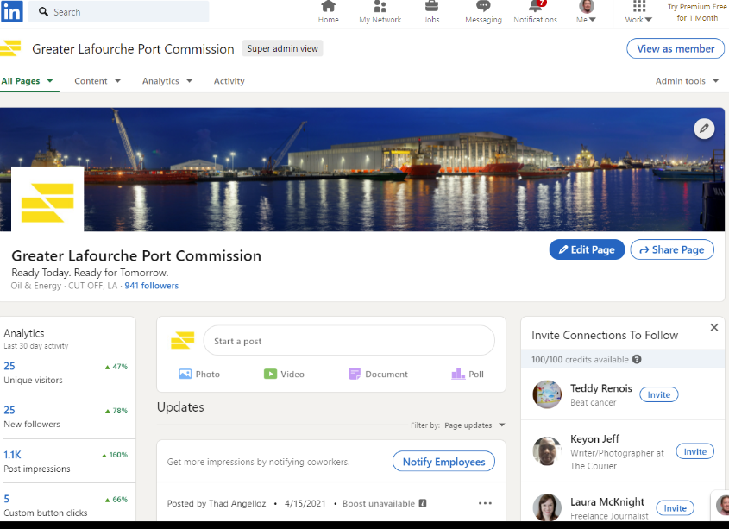





**Increase from 2019**

**41.95%**